NOTICE OF PLANNING COMMISSION
PUBLIC HEARING ON APPEAL
NATURE OF REQUEST | Appeal of the Planning Official’s approval with conditions of Oregon State University’s request to modify Conditional Use Permit LU-16-077 to include the approximately 4,950-foot (0.94-mile) Snack Time Trail.
PUBLIC HEARING | Tuesday, November 3, 2026, 6:00 p.m.  Kalapuya Building, 4500 SW Research Way, Corvallis
PROPERTY LOCATION | McDonald-Dunn Research Forest, north of Corvallis, near the terminus of NW Oak Creek Drive. Snack Time connects Lower Play Time and Uproute.
APPLICANT / OWNER | Oregon State University, College of Forestry
APPELLANTS | Daniel Rosenberg, Jennifer Gervais, Steve Cook, and Terri Cook represented by Hutchingson Cox, Zack P. Mittge
ZONE / PLAN | Forest Conservation (FC) / Forestry
REVIEW PROVISIONS | BCC 53.215, 53.220, 53.225, 53.230, 60.215(1), and 60.220; applicable conditions of LU-16-077; OAR 660-034-0040. Procedural provisions include BCC 51.205, 53.150, 53.160, and 51.805–51.840.
STAFF CONTACT | Petra Schuetz, Planning Official  petra.schuetz@bentoncountyor.gov | 541-766-6819
NOTICE DATE | October 15, 2026
You are receiving this notice as a nearby property owner or a person entitled to notice of the appeal hearing. The administrative approval is stayed pending resolution of the appeal by County appellate authorities.
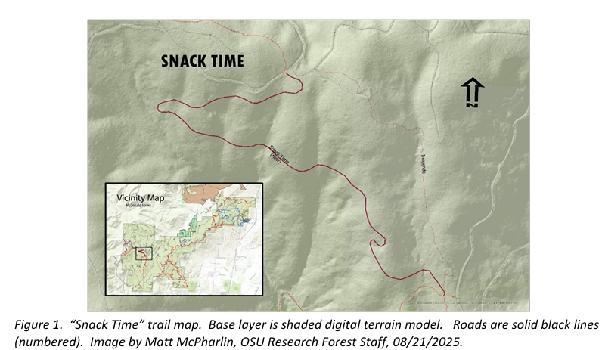
What is being appealed?
The appellants allege expiration of the underlying permit; improper administrative review; insufficient changed circumstances and findings; impacts on neighboring uses, public services, farming and forestry, and fire safety; and failure to meet forest-zone and park master-planning requirements. These are allegations for the Commission to consider, not County conclusions.
How will the hearing work?
The hearing is de novo: the Commission will independently review the application and receive relevant testimony, arguments, and evidence, including new materials. Issues are not limited to those stated in the appeal. The applicant will testify first, followed by supporters, opponents beginning with the appellants, governmental bodies (if applicable), and applicant rebuttal. The Commission may affirm, reverse, or modify the decision and will adopt findings.
Do you want to comment?
You may testify at the November 3, 2026 hearing or submit written testimony from the notice date until the public testimony record closes. Direct testimony to the applicable criteria or other criteria you believe apply. Include your name, mailing address, and File No. LU-26-030. Email submissions must expressly request inclusion in the hearing record and reach the staff contact during the comment period.
Submit testimony by mail, drop-off, or email:
Benton County Community Development
4500 SW Research Way, Corvallis, OR 97333
permitcheck@bentoncountyor.gov
Where can you review the materials?
The application, appeal, documents and evidence relied upon by the applicant, and applicable criteria are available at https://cd.bentoncountyor.gov/land-use-applications-in-review/ and for inspection without charge at Community Development. Copies are available at cost. The hearing staff report will be available at least seven days before the hearing—October 27, 2026. For access or accommodation arrangements, contact 541-766-6819.
How will you learn the decision?
Notice of the Planning Commission’s decision will be mailed only to persons who testify orally or in writing. The notice will explain any further appeal rights.
Failure to raise an issue orally or in writing before the final evidentiary record closes, with sufficient specificity for the County and parties to respond, precludes an appeal to the Land Use Board of Appeals based on that issue.
NOTICE TO MORTGAGEE, LIENHOLDER, VENDOR, OR SELLER: ORS CHAPTER 215 REQUIRES THAT IF YOU RECEIVE THIS NOTICE IT MUST BE PROMPTLY FORWARDED TO THE PURCHASER.
The recipient of this notice is hereby responsible for forwarding a copy of this notice to every person with a documented interest, including a renter or lessee.

