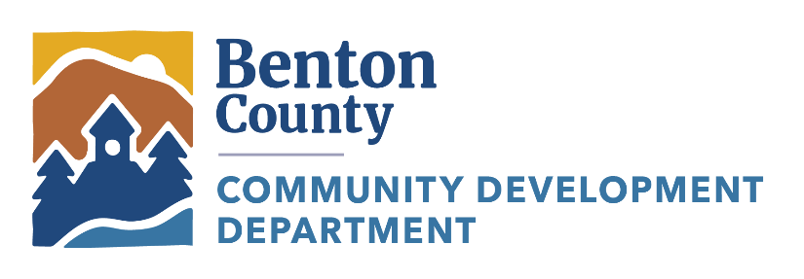
Community Development Department
Office: (541) 766-6819
4500 SW Research Way
Corvallis, OR 97333
co.benton.or.us/cd

DATE: June 18, 2024
NOTICE TO: Banks, Lending Institutions, and Real Estate and Insurance Agents
Please route this notice to everyone in your office.
FROM: Toby Lewis, Floodplain Administrator, CFM – Benton County Community Development
SUBJECT: Flood Insurance Rate Map Information

The Community Development Department is open Monday through Friday. Please refer to our website for counter hours. If you have a question about flood hazard for a property, please contact us at (541) 766-6819. Our front desk staff will route your call to the correct people to answer your questions.

When you call: Please remember to provide the tax assessor's map and tax lot number and/or the street address so we can quickly find information to answer your questions.

The Benton County floodplain program provides information to help answer the following questions:
- Is my property located in or near the Special Flood Hazard Area (floodplain)?
- What information from the Flood Insurance Rate Map is helpful for my lender, insurance agent, or surveyor?
- Is there additional flood hazard information – such as type of flood zone, base flood elevation or depth, or new preliminary studies – available for my property?
- My property is in a flood hazard area. What land use and building code requirements apply to my property or my project?
- Can I have a copy of the Flood Insurance Rate Map information showing the 100- and 500-year flood hazard boundaries and floodway locations?
- Is there an elevation certificate on file for any of the buildings on my property?
- I think my land or my building is higher than the expected flood elevation. How can I find out for sure and how can I document that?
- What should I know about flood insurance purchase requirements?
- Why is my lender requiring me to buy flood insurance?
- Where can I find out more about flood insurance options and coverage?
- What other information – such as floodways, potential flood depths, historical flood data, mapped wetland locations, and other natural floodplain functions – is available for my property?
If you would like a copy of any flood information, we can usually email it to you or you can purchase a paper copy.

Additional Information:
Helpful Benton County Flood Insurance Rate Map Dates:
- June 2, 2011 – Effective map date for most areas of Benton County.
- November 29, 2013 – Revision date for part of the Marys River between Fern Road and Bellfountain Road and part of the West Fork Newton Creek.
- December 8, 2016 – Revision date for most of the North Albany area.
- March 29, 2018 – Revision date for part of East Fork Newton Creek, west of Clemens Mill Road.
- March 28, 2019 – Revision date for parts of Hammer and Muddy Creeks, southwest of Alpine.
For information about local drainage issues, please call the Public Works Department at 541-766-6821.

Thank you for helping inform residents about flood risk in Benton County!

