- Section 3: Landfill Life Projections
- Waste in Place: Projection to End 2022
Definitions:
Landfill Life ≡ Expected time remaining in which the landfill will continue to accept waste, typically in Years.
End of Life (EOL) ≡ Expected calendar date when the landfill ceases to accept waste, typically in Calendar Years AD.
Franchisee, landfill owner = Republic Services

Intake at Coffin Butte Landfill in 2022 have not been finalized at the time of this writing, so we are using the projected figure of 1M tons. This gives us a projected volume of 16,008,557 cubic yards as of end-of-year 2022. This projected volume is Remaining Permitted Airspace, not available airspace; it includes a significant volume of unexcavated rock.

- Historical Landfill Life Projections
Figure ?: Historical EOL Projections (source: Landfill Annual Reports)

Figure 11: Historical EOL Projections (source: Landfill Annual Reports)

Table ?: Historical EOL Projections
Table 5: Historical EOL Projections
Date of Projection | Projected EOL (CY) | Reference/Comment
1974? | 2000 | TBD
2001 | 2049 | 2001 Annual Report, prior to addition of East and West Triangles and Cell 6  47.5 years from Beginning 2002  Based on 425,000 Tons/year and 0.8 Tons/yd³
2003 | Late 2070 | 2003 Site Development Plan, Page 57, Table 3.1  71.1 Years from Oct 1999  Includes Cells 1-6 and East and West Triangles  Based on 400,000 Tons/year and 0.8 Tons/yd³
2010 | 2053 | United States Environmental Protection Agency*
2013 | 2064 | United States Environmental Protection Agency*
2014 | 2065 | United States Environmental Protection Agency*
2015 | 2061 | United States Environmental Protection Agency*
2016 | 2058 | United States Environmental Protection Agency*
2018 | 2048 | United States Environmental Protection Agency*
2019 | 2044 | United States Environmental Protection Agency*
2021 | 2039 | 2021 Site Development Plan, Appendix B  With detailed breakdown of planned Cell 6 structure and corresponding subcell life expectancy  Based on 846,274 Tons/year and 0.8 Tons/yd³
* EPA Greenhouse Gas (GHG) Emissions Data from Large Facilities, 2010-2021

Table
(a note on table above) (another note on table above)

- The U.S. Environmental Protection Agency projects the landfill EOL to be CY 2044. The assumptions behind this projection are not available to be examined.
- The 2021 Site Development Plan filed by the landfill owner with the Oregon Department of Environmental Quality projects the landfill EOL to be CY 2039, based on an annual intake of 846,274 Tons/year and a density of 0.8 Tons/yd3. Other assumptions behind this projection are not available to be examined.

- Nominal Life Projection CY 2023 to End of Life<organizational note>
The landfill life projections shown below are provided by the franchisee.
Work in-progress, and items to address in this section:

The figure below (Figure 3B-1) establishes a baseline, a simple operational projection that more sophisticated scenarios can be built upon. It is our baseline because it models the idealized parameters and longevity intended for the landfill by the landfill’s owner, which is: a steady annual intake of between 1M and 1.1M tons for the duration of the landfill’s 14.5-16 year site life (to 2037-2039). As indicated in its Assumptions, this baseline scenario is not a “default future”; it is not realistic, in that it references itself only and does not incorporate outside factors.

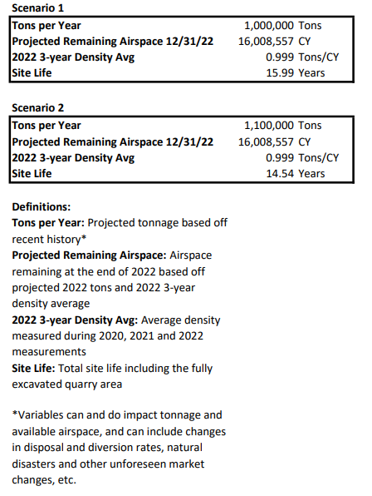

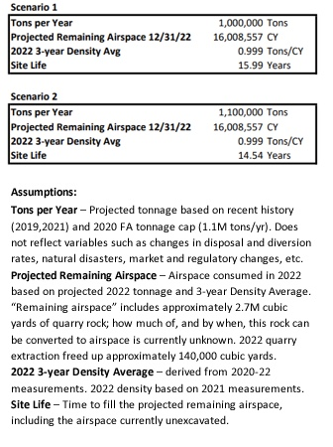

Density based off measurement from prior year.
< GRAPHIC EDIT: I updated the explanatory text to better communicate what we discussed about this baseline > Ken Eklund

Key Findings
- Current (1Q2023) estimate for landfill EOL = CY 2037 – 2039 based on an annual intake level of 1.0 – 1.1 MTons/year and a density of 0.999 Tons/yd³, assuming the quarry area will be fully excavated by the time the current disposal areas are full. The franchisee has represented that this nominal life projection (“baseline”) is derived from a few data points in annual measurements, and is the product of a modeling process that is standard in the landfill industry. The franchisee acknowledges that a variety of factors, including human factors, can impact landfill site life, but it is unknown which of these factors if any have been part of this baseline calculation. As of this writing, the franchisee represents that there will be no more information provided about how the baseline was derived, as their model and modeling process are proprietary.
- The landfill owner projects the landfill EOL to be CY 2037 – 2039 based on an annual intake of 1.0 – 1.1 MTons/year and a density of 0.999 Tons/yd3. The other assumptions behind this projection are not available to be examined.
- The quarry dynamics are construction of the needed cells for future disposal areas. The herculean construction task is to excavate basalt rock to form the excavated design dimensions for construction of future disposal cells. The assumption is that the excavated rock and the construction of future cells keep pace with the demands of increased volumes of refuse needed for disposal without interruption.
- The complexities of demand and availability of refuse disposal is the crux of the puzzle to provide a viable sustainable material management process under consideration.
- The below referenced Coffin Butte: Site Life Scenarios submitted by Republic Services is also a subject of the full Subcommittees Report that represents an array of elements for assumptions that can provide a correlation of topics in order to better analyze the capacity, size and longevity of Coffin Butte Landfill projections, especially within the short-term analysis of needing additional landfill disposal capacity during the current transitional bridge period with the BCTT Committee.
For example, the assumption that the “positive” element of Landfill expansion (CUP) alone against the net effects of the “negative” elements of "population growth and wildfires/natural disasters” will within the economies of scope and economies of scale will likely exceed tonnage cap disposal limitation that are reflected in the current landfill franchise agreement.
Likewise, the assumption of “positive” elements of “Landfill expansion (CUP)” and “Transfer Station/Disposal alternatives” against the net effects of all of the “negative” elements of the array will in all likelihood within the economies of scope and the economies of scale produce a better-balanced cost effective and economical result of refuse disposal for Benton County and neighboring municipalities and counties.
The intent above is not to imply an either/or solution, but assure that an evolving array of elements examined with sound economic principles along with savvy layman thought and professional understanding can produce a matrix that best support a circular economy that is still heavily reliant on a sanitary engineered landfill refuse disposal site during the embryonic stages of the circular economy development being considered by BCTT’s sustainable material management sub-committee.

Key Recommendation
- The Sustainable Materials Management Plan should further develop scenarios and factors that may impact the landfill lifespan, including detailed analyses of likely projections.

Key Recommendation
- The Sustainable Materials Management Plan should further develop scenarios and factors that may impact the landfill lifespan, including detailed analyses of likely projections.

Scenario 1
Tons per Year 1,000,000 Tons
Projected Remaining Airspace 12/31/22 16,008,557 CY
2022 3-year Density Avg 0.999 Tons/CY
Site Life 15.99 Years

Scenario 2
Tons per Year 1,100,000 Tons
Projected Remaining Airspace 12/31/22 16,008,557 CY
2022 3-year Density Avg 0.999 Tons/CY
Site Life 14.54 Years

Definitions:
Tons per Year: Projected tonnage based off
recent history*

Projected Remaining Airspace: Airspace
remaining at the end of 2022 based off
projected 2022 tons and 2022 3-year density average

2022 3-year Density Avg: Average density
measured during 2020, 2021 and 2022, measurements

Site Life: Time to fill the projected remaining airspace, including the airspace currently unexcavated in the quarry area, given the projected Tons per Year intake rate

*Variables can and do impact tonnage and
available airspace, and can include changes
in disposal and diversion rates, natural
disasters and other unforeseen market
changes, etc.

Comment
The baseline stands in contrast to what the U.S. Environmental Protection Agency currently lists as the projected end-of-life year for Coffin Butte Landfill: 2044, as displayed in Section B. Historical Landfill Life Projections, above. This estimate also relies on data from the franchisee, but is calculated using a different model.

We include an important note here: the A.1 Subcommittee members are not in agreement about the suitability of the baseline to characterize the longevity of the landfill. In general, the franchisee subcommittee members feel the baseline is an adequate characterization and other community subcommittee members feel it is not; the franchisee members feel that other characterizations are too speculative to be included and community members feel they are vital to understand the landfill’s true situation regarding its longevity. These disagreements can be considered to generally apply in the material that follows.

The A.1 subcommittee is charged to research and document the assumptions behind the operating life of Coffin Butte Landfill. It has also been charged by the Workgroup to develop not a singular projection, but scenarios to lay out possible and likely influences upon the landfill’s longevity. The goal of our end product is to create value for the Board of Commissioners, the government, and the people of Benton County, whose questions and concerns are not addressed by the franchisee’s model, which seems to optimize for the intake rate and longevity intended for the landfill by the franchisee and discounts or ignores counterfactors. It’s also common sense not to rely on a single, proprietary model to characterize something as complex as the operating life of Coffin Butte Landfill.

Presenting a single answer to the question “What is the longevity of the Coffin Butte Landfill?” implies that all known major factors influencing that answer have been accounted for. It generates questions such as “What does this number assume happens to recycling rates?” and “Has this number factored in Oregon’s extended producer responsibility (EPR) initiative?” and so on. The baseline has been acknowledged not take major factors into account and itself is unavailable for querying. The subcommittee has undertaken a listing of major factors and a querying of several “what if” questions; this exploration of this operating future is summarized in the next Subsection, D. Events and Factors with Potential Lifetime Impact.

(These I believe are qualifiers to the numbers in Figure 3B-1. Someone should write them out for real but I don’t feel qualified to do that)
Likely somewhere between the two scenarios – 14.54-15.99 year site life*.
- Derived from Republic Services annual measurements
- Describe the underlying method for calculating these numbers
- List assumptions
- *Includes quarry, which currently has unexcavated rock
- Quarry sequencing/staging – timeline and description. May be combination of options.
- Where the landfill is currently receiving waste stands over a number of previous cells. At the time of transition to place liner in the quarry, they will be starting a new footprint, without a lot of area to fill on top of or against. Considering efficiencies of fill and stability of hill. Larger footprint needed when starting fill that is not leaning against existing fill/cell.
- Add potential factors that could change the site development plan expectations

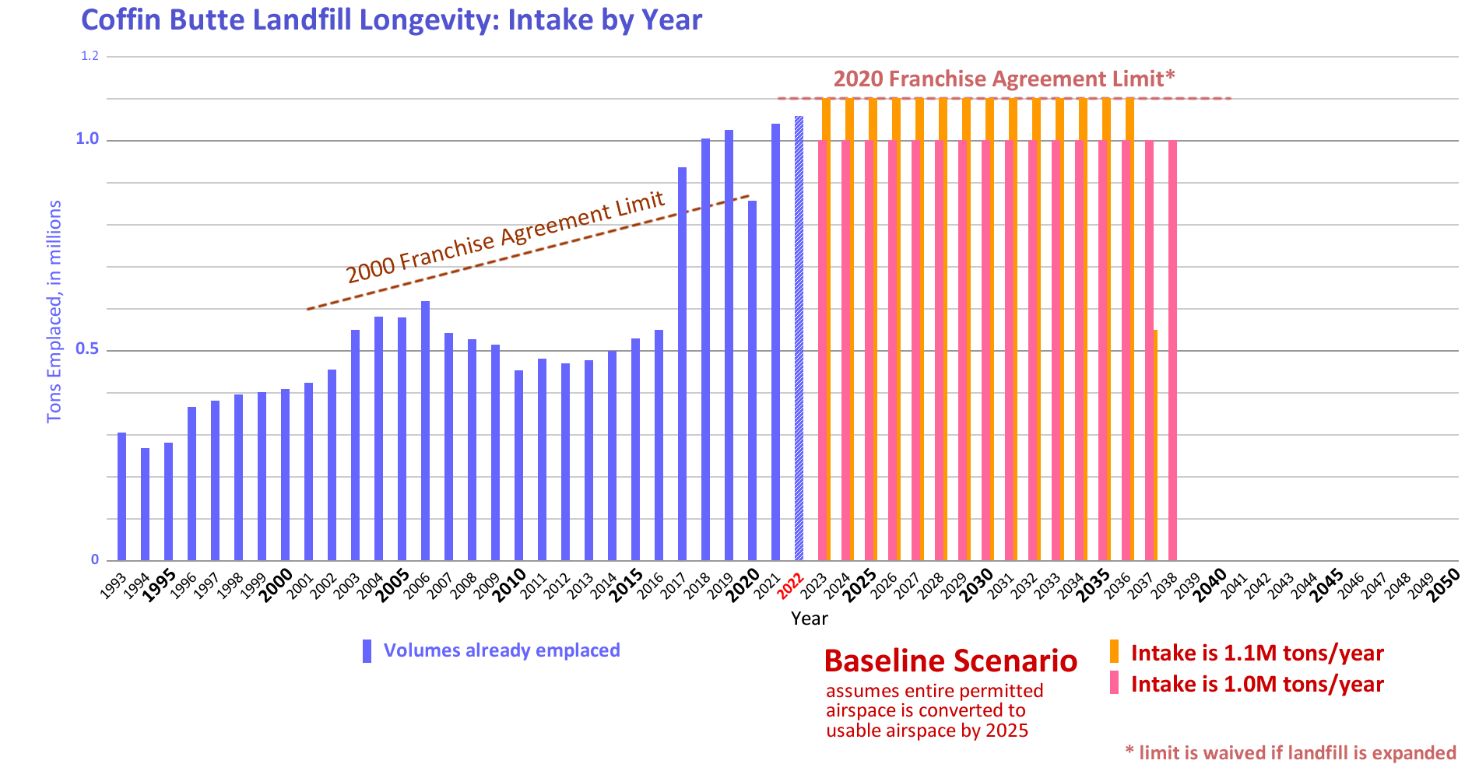
The longevity timeline in the baseline is shown in Figure 3B-2; this figure includes historic data for context.
The baseline is a simple longevity projection prepared by the landfill owner for operational purposes, and by design does not reflect the influence of real-world variables. To estimate the landfill’s real-world operational lifetime, these influences must be considered. We have identified some of these influences and outline their possible effects in Section 3C. For simplicity’s sake, we will use the 1.1M tons/year assumption (“Scenario 2”) and also assume full conversion of rock space in the quarry area into usable airspace as the baseline in Section 3C.
- Events and Factors with Potential Lifetime Impact
Work In-Progress: Working on coming to consensus on how much detail to include in this section and the scenario sections that follow.
As seen in the two baseline scenarios above, the landfill’s lifespan is generally determined by a calculation of three variables:
- Amount of space available (airspace)
- Amount waste is accepted (tonnage)
- Density of the waste (tons per cubic yard)
The main discussion in this section is around the various factors that impact the first and second variables above, the amount of space available (airspace), and the amount waste is accepted (tonnage) respectively. Almost none of the factors relate to density of solid waste, so this discussion excludes that variable. The following graphic summarizes possible impacts of various factors on site life:
Figure x:
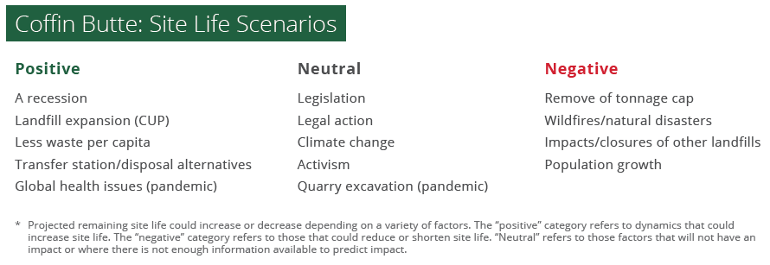
The below referenced Coffin Butte: Site Life Scenarios submitted by Republic Services is also a subject of the full Subcommittees Report that represents an array of elements for assumptions that can provide a correlation of topics in order to better analyze the capacity, size and longevity of Coffin Butte Landfill projections, especially within the short-term analysis of needing additional landfill disposal capacity during the current transitional bridge period with the BCTT Committee.
For example, the assumption that the “positive” element of Landfill expansion (CUP) alone against the net effects of the “negative” elements of "population growth and wildfires/natural disasters” will within the economies of scope and economies of scale will likely exceed tonnage cap disposal limitation that are reflected in the current landfill franchise agreement.
Likewise, the assumption of “positive” elements of “Landfill expansion (CUP)” and “Transfer Station/Disposal alternatives” against the net effects of all of the “negative” elements of the array will in all likelihood within the economies of scope and the economies of scale produce a better-balanced cost effective and economical result of refuse disposal for Benton County and neighboring municipalities and counties.
The intent above is not to imply an either/or solution, but assure that an evolving array of elements examined with sound economic principles along with savvy layman thought and professional understanding can produce a matrix that best support a circular economy that is still heavily reliant on a sanitary engineered landfill refuse disposal site during the embryonic stages of the circular economy development being considered by BCTT’s sustainable material management sub-committee.
HERE BEGINS THE ALTERNATE VERSION OF THE LIST ITEMS AS FACTORS POTENTIALLY AFFECTING LANDFILL LONGEVITY (“ALTERNATE VERSION”). THE LAST ITEM IN THIS VERSION IS “TONNAGE VOLUME IN THE BROADER MARKET” THAT ENDS ON PAGE 67. THE ORIGINAL VERSION BEGINS ON PAGE 67 AND CONTINUES THROUGH PAGE 74. THE ORIGINAL VERSION WAS SUBMITTED TO THE SUBCOMMITTEE IN EARLY JANUARY; THE ALTERNATE VERSION IS JUST NOW AVAILABLE FOR COMMENT & EDITING. THE SUBCOMMITTEE IS CURRENTLY TAKING UP THE QUESTION OF HOW TO RECONCILE THE ORIGINAL WITH THE ALTERNATE.

These factors generally impact one another in complex ways. The direction of impact (increasing or decreasing lifespan), magnitude of impacts, and the dynamics between each factor is largely unknown by this subcommittee. However, this subcommittee has taken an initial guess at outlining several factors below which have the potential to impact the variables above, and thus the landfill’s lifespan. Impacts on the landfill’s lifespan may not be immediate, but experienced over the course of years. The discussion below simply lists factors, provides some background information on how they relate to the landfill’s lifespan, includes an example of past events if available, and indicates how the factor could impact the lifespan. This section uses the following symbols to help inform the reader at a glance the various possibilities that the subcommittee determined are associated with each factor:
⬅️ - Decrease Landfill lifespan
❎ - No Change in Landfill lifespan
➡️ - Decrease Landfill lifespan
❓ - Unknown Impacts to Landfill lifespan
⬅️ ❎ ➡️ ❓
Although the physical parameters of Coffin Butte Landfill play a role in its longevity, human factors drive the actual outcome, because they determine the inflow of material that fills up the landfill’s permitted volume (and shape that volume itself). Unlike the physical factors, human factors – by which we mean decisions and agreements such as business and legal obligations, legislation, enforcement, civic action and attitudes, technological advances, risk assessments and risk taking, individual and collective values and choices, and so on – have the power to shift the landfill’s operating life very quickly. Estimations of the operating life of the Coffin Butte Landfill necessarily rely on assessments of and assumptions about the entire system that feeds waste to the landfill, and this wider system is created by, motivated by, operated by, and continuously being changed by human factors and the events they bring about.
The subcommittee has generated a List of potential factors impacting site life, and characterized some of them briefly and others in more detail. Our goal was to begin to describe the “terrain” that the landfill’s future will traverse. This list is not exhaustive and our characterizations are limited; we hope a more complete list and more detailed characterizations will come as Benton County prepares a Sustainable Materials Management Plan.
We include an important note here: the A.1 Subcommittee members are not in agreement about the inclusion of some of the List items or the characterization of List items. Generally, the franchisee subcommittee members supported a shorter list of items, in bullet form only (no characterizations), whereas other community subcommittee members supported the full List and their characterizations.
Other Notes:
- For simplicity’s sake only, we will use the 1.1M tons/year assumption (“Scenario 2”) as the baseline throughout.
- For simplicity’s sake only, we will assume full conversion of rock space in the quarry area into usable airspace for the baseline.
- Factors that shorten landfill life but are subject to the intake cap will effectively help the franchisee keep intake at baseline levels. They will not shorten landfill life beyond that.
- Factors that shorten landfill life and are not subject to the intake cap will shorten landfill life to be less than the baseline.

- Human factors – decisions and agreements such as business and legal obligations, legislation, enforcement, civic action and attitudes, technological advances, risk assessments and risk taking, individual and collective values and choices, and so on –drive the landfill’s actual longevity, because they determine the inflow of material that fills up the landfill’s actual volume.
- A range of human factors have been seen to influence the landfill’s intake rate and therefore its operating life in the past. These include business factors such as expansions or contractions of the wasteshed, social factors such as recessions and population growth, and environmental factors such as recycling and other initiatives that divert materials out of the wastestream.
- More human factors are emerging that will influence the landfill’s intake rate and therefore its operating life in the future. These include newly enacted state legislation assigning responsibility for disposal costs to the producers of waste material, newly enacted national legislation addressing food waste, and national legislation being rolled out that targets methane and other greenhouse gas pollution.

- Human factors – decisions and agreements such as business and legal obligations, legislation, enforcement, civic action and attitudes, technological advances, risk assessments and risk taking, individual and collective values and choices, and so on –drive the landfill’s actual longevity, because they determine the inflow of material that fills up the landfill’s actual volume.
- A range of human factors have been seen to influence the landfill’s intake rate and therefore its operating life in the past. These include business factors such as expansions or contractions of the wasteshed, social factors such as recessions and population growth, and environmental factors such as recycling and other initiatives that divert materials out of the wastestream.
- More human factors are emerging that will influence the landfill’s intake rate and therefore its operating life in the future. These include newly enacted state legislation assigning responsibility for disposal costs to the producers of waste material, newly enacted national legislation addressing food waste, and national legislation being rolled out that targets methane and other greenhouse gas pollution.

- Additional Events and Factors with Potential Lifetime Impact ORIGINAL VERSION FROM KEN
Although the physical parameters of Coffin Butte Landfill play a role in its longevity, human factors drive the actual outcome, because they determine the inflow of material that fills up the landfill’s permitted volume (and shape that volume itself). Unlike the physical factors, human factors – by which we mean decisions and agreements such as business and legal obligations, legislation, enforcement, civic action and attitudes, technological advances, risk assessments and risk taking, individual and collective values and choices, and so on – have the power to shift the landfill’s operating life very quickly. Estimations of the operating life of the Coffin Butte Landfill necessarily rely on assessments of and assumptions about the entire system that feeds waste to the landfill, and this wider system is created by, motivated by, operated by, and continuously being changed by human factors and the events they bring about.
The subcommittee has generated a Table of potential factors impacting site life, and characterized some of them briefly and others in more detail. Our goal was to begin to describe the “terrain” that the landfill’s future will traverse. This list is not exhaustive and our characterizations limited; we hope a more complete list and more detailed characterizations will come as Benton County prepares a Sustainable Materials Management Plan.

⬅️_Factors that shorten landfill life (trend the fill rate to baseline or beyond)

Landfill contracts and business choices
Landfilling at Coffin Butte is a business, subject to the standard pressures of customer loyalty, competitive pressure, price resistance, etc. This factor will tend to keep the landfill life at baseline, as the landfill owner strives to counteract any decline in intake by growing the wasteshed / by lowering prices, etc.
➡️⬅️ Shortens landfill life (only as far as the baseline)
This factor can also extend landfill life – loss of business, decrease in demand, operator’s choice to extend business longevity, etc.
This factor can also extend landfill life – loss of business, decrease in demand, operator’s choice to extend business longevity, etc.

Lifestyle changes
Our society is constantly affording new opportunities for consumers to participate in, and this increased economic activity tends to generate more waste.
➡️⬅️ Shortens landfill life (only as far as the baseline)
This factor can also extend landfill life – more consumer resistance to single-use items, causing a decrease in landfill demand
This factor can also extend landfill life – more consumer resistance to single-use items, causing a decrease in landfill demand

Quarry excavation schedule
Our baseline assumes that 100% of the landfill’s permitted airspace be converted into actual usable airspace before it is required for landfilling, but it is unclear at the time of this writing how much of the rock currently occupying the airspace is going to be successfully excavated. The timeline may require that some or all of the rock is left in place. Example: a similar situation occurred earlier in the landfill’s history, and quarryable rock was covered over with landfill.
An expanded discussion and visualization of this factor is included below.
⬅️ Shortens landfill life by not liberating landfill airspace

Water table concerns and regulation
A (currently unquantified) portion of the landfill’s permitted airspace seems to lie below the groundwater level, and it is unclear at this time whether or not Oregon DEQ regulations will allow this theoretical airspace to be used, or if permitted, will be cost-effective for the landfill owner to undertake. If the portion below the groundwater line is not usable / used, airspace would decrease and the lifespan of the landfill would shorten, in proportion to the volume affected.
⬅️ Shortens landfill life by not liberating landfill airspace
If the portion below the groundwater line is usable / used, airspace and the lifespan of the landfill would remain the same.

Area wildfires, floods, earthquakes and other disasters
Disasters can produce large amounts of debris. Example: Coffin Butte Landfill took in approximately 350,000 tons of debris in late 2020-early 2021 from the multiple area wildfires in 2020. The incidence of wildfire and flooding are generally expected to increase due to climate change. Disaster debris does not count toward the landfill’s intake cap.
⬅️ Shortens landfill life by consuming landfill airspace
The landfill can also choose not to accept as much disaster debris, where haulers would bring disaster debris further away, either not impacting landfill life or extending the landfill life, depending on how much disaster debris tonnage is already included in the baseline assumptions.
The landfill can also choose not to accept as much disaster debris, where haulers would bring disaster debris further away, extending the landfill life

Impacts to other disposal facilities
Coffin Butte Landfill currently takes in about ¼ 1/4 1/3 of the trash generated and disposed in Oregon. If a provider of the other 3/4 2/3 can no longer service its service area wasteshed, it creates a business opportunity for the landfill owner to expand the Coffin Butte service area wasteshed. Example: in 2016 the Riverbend Landfill in Yamhill County lost its bid to expand, and because it was nearly full, this enabled the landfill owner to capture its flows of approximately 500,000 tons of waste yearly for Coffin Butte Landfill.
➡️⬅️ Shortens landfill life only as far as the baseline, if intake cap is maintained
⬅️ Shortens landfill life if intake cap is set aside
This factor can also extend landfill life – new or expanded disposal facilities elsewhere may decrease demand at Coffin Butte Landfill. Similarly, and change that makes other disposal facilities more favorable (cost for haulers, etc) would decrease demand at Coffin Butte Landfill, extending the landfill life.
This factor can also extend landfill life – new or expanded disposal facilities elsewhere may decrease demand at Coffin Butte Landfill. Similarly, and change that makes other disposal facilities more favorable (cost for haulers, etc) would decrease demand at Coffin Butte Landfill, extending the landfill life.

Impacts to the waste recovery system
The landfill owner depends on outside suppliers for many services outside of landfilling, and if these relationships break down, then material that was formerly diverted ends up in the landfill. Example: Chinese recycling companies imposed new quality standards on imported recycled plastic in 2017-2018, and local recycling efforts could not meet those standards.
⬅️ Shortens landfill life by consuming landfill airspace
This factor can also extend landfill life – if waste recovery becomes more accessible (new MRFs, new processors, stronger markets for material, etc) the demand on the landfill would decrease.
This factor can also extend landfill life – if waste recovery becomes more accessible (new MRFs, new processors, stronger markets for material, etc) the demand on the landfill would decrease.

Population growth/Change
As the wasteshed adds more people, it also adds the waste they generate. Example: Benton County’s population is forecasted to grow steadily through 2071, with a population of over 120,000 in 2040.
⬅️ Shortens landfill life (only as far as the baseline)
This factor can also extend landfill life – if population moves out of the typical waste generation source counties (service areas), demand on the landfill could decrease.
This factor can also not impact landfill life – if population stays constant in the typical waste generation source counties, demand on the landfill could potentially not change.
This factor can also extend landfill life – if population moves out of the typical waste generation source counties, demand on the landfill could decrease.
This factor can also not impact landfill life – if population stays constant in the typical waste generation source counties,, demand on the landfill could potentially not change.

Localized fires, floods, spills and other disasters
Localized disasters can produce landfill material. Example: a fuel tanker that spilled on highway 9 generated many tons of contaminated dirt.
⬅️ Shortens landfill life by consuming landfill airspace
This factor can also either not impact or extend landfill life (depending on how much of this type of material is expected in the baseline scenarios) – if the landfill either chooses not to accept this material, or the hauler chooses a different facility,
This factor can also either not impact or extend landfill life (depending on how much of this type of material is expected in the baseline scenarios – if the landfill either chooses not to accept this material, or the hauler chooses a different facility,

⬅️⬅️_Factors that shorten landfill life (threaten landfill operations)

Landfill fire
Although it is very rare, landfills can catch fire, either on their surface or as exothermic reactions deep under their surface. The ubiquitous presence of methane, a flammable gas, is a risk factor. A landfill fire ignited by an area wildfire is a troubling possibility. Exothermic reactions are deep in the landfill itself and take years to extinguish.
⬅️ Shortens or ends landfill life by ending operations
This factor can also not impact landfill life, if the fire does not effect landfill operations and the ability to accept waste.
This factor can also extend landfill life, by reducing the amount of waste accepted temporarily while the operations are impacted, and then continuing operations with the full airspace available.
This factor can also not impact landfill life, if the fire does not effect landfill operations and the ability to accept waste.
(Note: if a landfill fire interrupts waste flow only temporarily, it might extend landfill life.)

This factor can also extend landfill life, by reducing the amount of waste accepted temporarily while the operations are impacted, and then continuing operations with the full airspace available.

➡️ Factors that lengthen landfill life (diminish the fill rate)

Landfill expansion – removal of tonnage cap
Expansion. The baseline assumes that no expansion occurs, and that the current available airspace is used. may only be fully realized in combination with a landfill expansion, which would create an alternate additional landfilling space site that allows time for the quarry airspace to be pre-excavated. The baseline assumes that no expansion occurs, and that the current available airspace is used. may only be fully realized in combination with A landfill expansion, which would create an alternate additional landfilling space site that allows time for the quarry airspace to be pre-excavated. The landfill owner has indicated that it will apply for such an expansion, likely in the first half of 2023. The new site would likely be the same as the 2021 application site, in the Landfill Site (LS) zone currently used for landfill operations south of Coffin Butte Road.
An expanded discussion and visualization of this factor is included below.
➡️ Extends landfill life by increasing permitted volume

Removal of tonnage cap. If an expansion is approved, by terms of the 2020 Franchise Agreement, the tonnage cap of 1.1M tons/year is removed, enabling the landfill owner to increase the Coffin Butte wasteshed without limit. If an expansion is approved, by terms of the 2020 Franchise Agreement, the tonnage cap of 1.1M tons/year is removed. This could enable the landfill owner to increase the Coffin Butte wasteshed without limit.
⬅️ Shortens landfill life by enabling increased fill rates
This factor can also either not impact or extend landfill life if the landfill’s demand does not change with the removal of the tonnage cap.

The two of these factors together would yield unknown results, because the magnitude of each are unknown.

This factor can also either not impact or extend landfill life if the landfill’s demand does not change with the removal of the tonnage cap.

The two of these factors together would yield unknown results, because the magnitude of each are unknown.

Successful competition from other disposal facilities
The landfill owner competes in the marketplace to establish and maintain the Coffin Butte wasteshed, and other facilities can and do successfully prevail. Example: although Washington County sent over 275,000 tons of waste to Coffin Butte Landfill in 2018, that amount decreased precipitously and was down to 36,000 tons in 2021, due presumably to successful competition by another disposal facility.
➡️ Extends landfill life by reducing source waste and therefore fill rate

Improvements to the waste recovery system / alternatives to landfilling
Waste recovery. We say the material headed for the landfill is “waste,” but the truth is, the majority of that material has productive utility. This profit incentive often is buttressed by cultural imperatives not to waste resources. The result is a wide array of initiatives at work ranging from system-wide resource recycling programs down to grassroots freesharing collaboratives. Examples: Too many to list, but the Food Donation Improvement Act, passed in 2022 with bipartisan support and signed into law in Jan 2023, aims to catalyze a major effort to address both hunger and the climate crisis by reducing food waste in America.
- Extends landfill life by reducing source waste and therefore fill rate

Landfill alternatives. Waste recovery is often augmented with measures that seek to prevent the harmful effects of landfilling, to get “beyond landfilling” by diverting materials to dedicated processing facilities or alternative disposal sites.
- Extends landfill life by reducing source waste and therefore fill rate

Obsolescence. Landfilling is an old technology, and alternative processes already exist. Examples of this abound in Europe, where EU member nations are working together to move beyond landfilling.
➡️ Extends landfill life by reducing source waste and therefore fill rate

Reductions in waste generation
Systemic. No one enjoys throwing things away, but the systems by which we acquire and use material goods are often designed to generate trash. These systems are being redesigned to either recycle materials or to eliminate their trash components. Examples: there are many to choose from, but a focus right now is extended producer responsibility (EPR) initiatives such as Oregon SB 582, the Plastic Pollution and Recycling Modernization Act passed in 2021, which provides “a much more accessible, responsible and stable recycling system.”
➡️ Extends landfill life by reducing source waste and therefore fill rate
Cultural. People individually can prioritize reducing waste, often in response to cultural or systemic cues. Example: the current recycling system relies on social engagement with issues of environmental awareness and action to inspire its volunteer actions to reuse, recycle, compost, etc. Historically, as shown in the historical data, this engagement goes up (and per-capita trash generation goes down) during Democratic administrations, when environmental issues are emphasized; the reverse is generally true during Republican administrations, when they are not.
- Extends landfill life by reducing source waste and therefore fill rate

Equity. Groups of people in the Coffin Butte wasteshed do not have equal access to recycling or other elements of waste reduction; measures are being designed to correct this. Example: Oregon SB 582, the Plastic Pollution and Recycling Modernization Act, contains provisions to fund reuse and waste prevention programs in these communities.
➡️ Extends landfill life by reducing source waste and therefore fill rate

Recessions
Recessions reduce economic activity, which generally reduces the amount of waste produced throughout the wasteshed. Example: the Crash of 2008 can explain in part the historical intake decline beginning in late 2008 and continuing through 2012.
➡️ Extends landfill life by reducing source waste and therefore fill rate

Materials transportation
Materials with inherent value currently go into landfills just because where they are is not where they need to be for that value to be extracted. Investments and improvements into relevant transportation systems (such as intermodal transfer stations, which enable materials to be shipped more economically by rail) can enable materials to become less wasteful and less environmentally harmful and participate more fully in circular economies.
➡️ Extends landfill life by reducing source waste and therefore fill rate

The climate crisis
Activism. People all over the world are growing increasingly concerned about the threat the uncontrolled release of greenhouse gases poses to the ecosystems that human societies depend upon. A major focus of activism worldwide is the release of methane, because methane is a potent and quick-acting greenhouse gas. While only 1.4% of emissions associated with the life cycle of materials in Oregon occur in the post-consumer disposal life-cycle stage (including landfilling and transportation to landfills), landfills are major sources of greenhouse gas emissions, especially methane, in the United States. Activism thus constitutes a powerful and growing force that is highly motivated to push forward actions that move beyond landfilling. Example: grassroots environmental activists successfully prevented landfill owners from expanding their landfills in both Yamhill and Benton counties in the last ten years.
➡️ Extends landfill life by reducing methane-generating waste going into the landfill

Litigation and Shareholder Action. Environmentally engaged citizens are suing governmental agencies, and investors are suing corporations, for failing to act responsibly on the climate crisis, and to force action to address the crisis. Example: the worldwide campaign of atmospheric trust litigation organized by Our Children’s Trust, a public interest nonprofit law firm headquartered in Eugene.
➡️ Extends landfill life by reducing methane-generating waste going into the landfill

Legislation. The pressure generated by the public, science, financial, and industry communities concerned about the climate crisis is manifesting in legislation. Examples: in its 2021 Methane Emissions Reduction Plan, the US government is mobilizing “all available tools to identify and reduce methane emissions from all major sources,” and in its 2023 Food Donation Improvement Act, it targets food waste, “the most common material found in landfills, constituting an estimated 24% of material” which generates large quantities of methane emissions.
➡️ Extends landfill life by reducing methane-generating waste going into the landfill

➡️⬅️ Novel factors on landfill life

Pandemics
The COVID pandemic has had a significant but mixed impact on landfill life, which can be characterized as a profound reduction in waste generation in 2020 and a resurgence of waste generation in 2021, likely due to lifestyle adaptations such as increased at-home shopping. The pandemic will continue to have an effect as long as it is endemic.
➡️ Extends landfill life by reducing economic activity and therefore fill rate
➡️⬅️ Trends toward baseline by incentivizing activities that generate more waste

(These bullet points not yet addressed in the text above)

(These bullet points not yet addressed in the text above)
- Climate change impacts to landfill operations
- Landfill facility and technical challenges
- Staffing in the local and regional solid waste industry
- adjustments in diversion/recycling rates, and
- tonnage volume in the broader market.

Selected scenario expanded views
To help with visualizing the factors, a few of them are discussed in greater detail below.

- Factors Impacting Amount of space available (airspace) ALTERNATE VERSION BY DANIEL, BASED ON KEN’S ORIGINAL VERSION
- Quarry excavation schedule ⬅️ ❎
  - Our baseline assumes that 100% of the landfill’s permitted airspace be converted into actual usable airspace before it is required for landfilling, but it is unclear at the time of this writing how much of the rock currently occupying the airspace is going to be successfully excavated. The timeline may require that some or all of the rock is left in place.
  - ❎ If the quarry is fully excavated by the time the current cell is filled, the landfill’s airspace is expected to remain at the estimated 16,008,557 CY, with no changes to the calculated lifespan.
  - ⬅️ If the quarry is not fully excavated by the time the current cell is filled, the landfill’s airspace is expected to decrease below 16,008,557 CY, with a reduction in lifespan.

- DEQ regulations regarding cell development below the water table ⬅️ ❎ ➡️ ❓
  - A (currently unquantified) portion of the landfill’s permitted airspace seems to lie below the groundwater level, and it is unclear at this time whether or not Oregon DEQ regulations will allow this theoretical airspace to be used, or if permitted, will be cost-effective for the landfill owner to undertake. If the portion below the groundwater line is not usable / used, airspace would decrease and the lifespan of the landfill would shorten, in proportion to the volume affected.
  - ❎ If the quarry is allowed to be fully excavated by the time the current cell is filled, the landfill’s airspace is expected to remain at the estimated 16,008,557 CY, with no changes to the calculated lifespan.
  - ⬅️ If the quarry is not allowed to be fully excavated by the time the current cell is filled, the landfill’s airspace is expected to decrease below 16,008,557 CY, with a reduction in lifespan.

- Landfill Expansion ➡️ ❓
  - The baseline assumes that no expansion occurs, and that the current available airspace is used. A landfill expansion would create an alternate additional landfilling space in addition to what is currently listed as available airspace (16,008,557 CY). The landfill owner has indicated that it will apply for such an expansion, likely in the first half of 2023. The new site would likely be the same as the 2021 application site, in the Landfill Site (LS) zone currently used for landfill operations south of Coffin Butte Road.
  - ➡️ Extends landfill life by increasing permitted volume
  - ❓ A combination of an expansion and removal of tonnage cap (detailed below) , which would occur simultaneously, would yield unknown results, because the magnitude of each are unknown.

MISSING

- Factors Impacting Amount waste is accepted (tonnage)
Most of the factors discussed relate more specifically to the amount of waste accepted. Coffin Butte Landfill’s operator generally chooses how much tonnage to accept, based on demand and their agreements with various jurisdictions and haulers. The following factors are related to those that impact tonnage accepted at the landfill by impacting the landfill’s demand, and the subcommittee have taken an initial guess at how these factors may impact demand:

- Landfill Demand (contracts and business choices) ⬅️ ❎ ➡️
  - ⬅️ Decreases lifespan if landfill increases business and agrees to accept more waste per year, increasing demand.
  - ❎ No change to lifespan if the landfill business stays the same, accepting the same amount of waste, and maintaining constant demand.
  - ➡️ Increases lifespan if landfill decreases business and accepts less waste per year, decreasing demand.

- Recession ➡️ ❎
  - Recessions reduce economic activity, which generally reduces the amount of waste produced per-capita.
  - ➡️ Increases lifespan if per-capita waste for landfill’s service area decreases, decreasing demand.
  - ❎ No change to lifespan if per-capita waste for landfill’s service area done not change, maintaining demand.
  - Example: 2008 Recession was attributed in part to decreases in waste accepted from 2006-2010.

- Economic Growth ⬅️ ❎
  - Increased economic activity from economic growth generally increases the amount of waste produced per-capita.
  - ⬅️ Decreases lifespan if per-capita waste for landfill’s service area increases, decreasing demand.
  - ❎ No change to lifespan if per-capita waste for landfill’s service area does not change, maintaining demand.

- Natural Disasters ⬅️ ❎ ➡️
  - Disasters can produce large amounts of debris. Natural disasters like wildfires and flooding are generally expected to increase due to climate change, along with their debris. Disaster debris does not apply toward the landfill’s intake cap.
  - ⬅️ Decreases lifespan if natural disasters increase demand, and the landfill agrees to accept more natural disaster debris per year.
  - ❎ No change to lifespan if natural disasters do not change demand, and the landfill’s intake tonnage remains constant.
  - ➡️ Increases lifespan if natural disasters decrease demand by impacting the landfill’s ability to accept waste (via reduced landfill access, for example).
  - Example: 2020 wildfire debris contributed to tonnage accepted by the landfill in 2020 and 2021.

- Impacts to other disposal facilities ⬅️ ❎ ➡️ ❓
  - Coffin Butte Landfill currently takes in about 1/4 of the trash generated and disposed in Oregon. If a provider of the other 3/4 can no longer service its service area, it creates a business opportunity for the landfill owner to expand the Coffin Butte service area. Similarly, if another facility can capture business from an area or customer base currently served by Coffin Butte Landfill, then Coffin Butte Landfill’s service area would decrease.
  - ⬅️ Decreases lifespan if there is an increase in demand through impacts to other facilities, and the landfill agrees to accept more materials per year.
  - ❎ No change to lifespan if there is no change in demand, and the landfill’s intake tonnage remains constant.
  - ➡️ Increases lifespan if there is a decrease in demand through growth of other facility’s businesses, and the landfill accepts less material per year.
  - ❓ It is unclear how impacts of simultaneously expanding and contracting customer bases (shifts in customer base) would impact lifespan.
  - Example: in 2016 the Riverbend Landfill in Yamhill County lost its bid to expand, and because it was nearly full, this enabled the landfill owner to capture its flows of approximately 500,000 tons of waste yearly for Coffin Butte Landfill.
  - Example: although Washington County sent over 275,000 tons of waste to Coffin Butte Landfill in 2018, that amount decreased precipitously and was down to 36,000 tons in 2021, due presumably to successful competition by another disposal facility.

- Localized fires, floods, spills and other disasters ⬅️ ❎ ➡️
  - Localized disasters can produce landfill material.
  - ⬅️ Decreases lifespan if disasters increase demand, and the landfill agrees to accept more disaster debris per year.
  - ❎ No change to lifespan if natural disasters do not change demand, and the landfill’s intake tonnage remains constant.
  - ➡️ Increases lifespan if disasters decrease demand by impacting the landfill’s ability to accept waste (via reduced landfill access, for example).
  - Example: a fuel tanker that spilled on Highway 99 generated many tons of contaminated dirt, which the landfill accepted.

- Changes to waste recovery system ⬅️ ❎ ➡️ ❓
  - The waste recovery system, composed of service providers, materials collectors, material recovery facilities, material processors, recycled material markets, and more, can impact the demand on the landfill. We say the material headed for the landfill is “waste,” but the majority of that material has productive utility. This profit incentive often is buttressed by cultural imperatives not to waste resources. The result is a wide array of initiatives at work ranging from system-wide resource recycling programs down to grassroots freesharing collaboratives.
  - ⬅️ Decreases lifespan if there is an increase in landfill demand through negative impacts to the material recovery system, and the landfill agrees to accept more materials per year.
  - ❎ No change to lifespan if there is no change in demand, and the landfill’s intake tonnage remains constant.
  - ➡️ Increases lifespan if there is a decrease in demand through positive impacts to the material recovery system, like new recovery facilities or growth in market for recovered materials, and the landfill accepts less material per year.
  - ❓ It is unclear how impacts of simultaneously expanding and contracting customer bases (shifts in customer base) would impact lifespan.
  - Example: China’s 2017-2018 policies on importing waste materials reduced the ability for Oregon recyclers to export materials, changing the standards for recycling in Oregon, decreasing recycled materials, and increasing disposal.
  - Examples: Too many to list, but the Food Donation Improvement Act, passed in 2022 with bipartisan support and signed into law in Jan 2023, aims to catalyze a major effort to address both hunger and the climate crisis by reducing food waste in America.

- Population Change ⬅️ ❎ ➡️ ❓
  - As the landfill’s service area adds more people, it also adds the waste they generate. Similarly, as the population decreases in the landfill’s service area, the per-capita waste can decrease.
  - ⬅️ Decreases lifespan if there is an increase in demand through population growth and per-capita disposal either grows or stays constant, and the landfill agrees to accept more materials per year.
  - ❎ No change to lifespan if there is no change in demand, and the landfill’s intake tonnage remains constant.
  - ➡️ Increases lifespan if there is a decrease in demand through population decline and per-capita disposal either declines or stays constant, and the landfill accepts less material per year.
  - Example: Benton County’s population is forecasted to grow steadily through 2071, with a population of over 120,000 in 2040

- Removal of tonnage cap ⬅️ ❎ ➡️
  - If an expansion is approved, by terms of the 2020 Franchise Agreement, the tonnage cap of 1.1M tons/year is removed, enabling the landfill owner to increase the Coffin Butte wasteshed without limit.
  - ⬅️ Shortens landfill life by enabling increased fill rates, if the landfill demand also increases and the landfill accepts more waste material.
  - ❎ No change to lifespan if removal of tonnage cap does not change demand, and the landfill tonnage intake remains constant.
  - ➡️ Increases landfill life if the landfill demand decreases and the landfill accepts less waste material.

- Availability of landfill alternatives ⬅️ ❎ ➡️
  - Outside of maximized recovery (recycling and composting) and waste prevention, alternatives to landfilling exist in various forms, primarily in different disposal technology. An incinerator in Marion County burns waste and generates energy, for example.
  - ⬅️ Decreases lifespan if there is an increase in landfill demand through impacts to other disposal facilities (like the closure or temporary closure of an alternative dispal facility), and the landfill agrees to accept more materials per year.
  - ❎ No change to lifespan if there is no change in demand, and the landfill’s intake tonnage remains constant.
  - ➡️ Increases lifespan if there is a decrease in demand through growth of other facility’s businesses, and the landfill accepts less material per year.

- Lifestyle of waste generators ⬅️ ❎ ➡️
  - Changing lifestyles regarding material consumption (how much stuff people buy), and general materials management (how people choose to reduce, reuse, recycle, and dispose), have an impact on per capita waste generation.
  - ⬅️ Decreases lifespan if it increases demand through increased disposal, and the landfill agrees to accept more waste material per year.
  - ❎ No change to lifespan if there is no change in demand, and the landfill does not change material intake per year.
  - ➡️ Increases lifespan if it decreases demand through decreased disposal, and the landfill does not accept more waste material per year.

- Legislation impacting landfill operations ⬅️ ❎ ➡️ ❓
  - The pressure generated by the public, science, financial, and industry communities concerned about the climate crisis is manifesting in legislation.
  - ⬅️ Decreases lifespan if it increases demand through increased disposal, and the landfill agrees to accept more waste material per year.
  - ❎ No change to lifespan if there is no change in demand, and the landfill does not change material intake per year.
  - ➡️ Increases lifespan if it decreases demand through decreased disposal, and the landfill does not accept more waste material per year.
  - Examples: in its 2021 Methane Emissions Reduction Plan, the US government is mobilizing “all available tools to identify and reduce methane emissions from all major sources,” and in its 2023 Food Donation Improvement Act, it targets food waste, “the most common material found in landfills, constituting an estimated 24% of material” which generates large quantities of methane emissions.
  - Examples: The commerce clause prevents Benton County from limiting the source of waste materials into the landfill.

- Legislation impacting waste generation ⬅️ ❎ ➡️
  - ⬅️ Decreases lifespan if it increases demand through increased disposal, and the landfill agrees to accept more waste material per year.
  - ❎ No change to lifespan if there is no change in demand, and the landfill does not change material intake per year.
  - ➡️ Increases lifespan if it decreases demand through decreased disposal, and the landfill does not accept more waste material per year.

- Legal Action ⬅️ ❎ ➡️
  - Environmentally engaged citizens are suing governmental agencies, and investors are suing corporations, for failing to act responsibly on the climate crisis, and to force action to address the crisis. Legal action can also increase landfill demand.
  - ⬅️ Decreases lifespan if it increases demand through increased disposal, and the landfill agrees to accept more waste material per year.
  - ❎ No change to lifespan if there is no change in demand, and the landfill does not change material intake per year.
  - ➡️ Increases lifespan if it decreases demand through decreased disposal, and the landfill does not accept more waste material per year.
  - Example: the worldwide campaign of atmospheric trust litigation organized by Our Children’s Trust, a public interest nonprofit law firm headquartered in Eugene.
  - Example: Legal action regarding the commerce clause prevent Benton County from limiting the source of waste materials into the landfill.

- Activism ⬅️ ❎ ➡️
  - People all over the world are growing increasingly concerned about the threat the uncontrolled release of greenhouse gases poses to the ecosystems that human societies depend upon. A major focus of activism worldwide is the release of methane, because methane is a potent and quick-acting greenhouse gas. While only 1.4% of emissions associated with the life cycle of materials in Oregon occurre in the post-consumer disposal life-cycle stage (including landfilling and transportation to landfills), landfills are major sources of greenhouse gas emissions, especially methane, in the United States. Activism thus constitutes a powerful and growing force that is highly motivated to push forward actions that move beyond landfilling. Similarly, a variety of activist efforts can drive demand to the landfill.
  - ⬅️ Decreases lifespan if it increases demand through increased disposal, and the landfill agrees to accept more waste material per year.
  - ❎ No change to lifespan if there is no change in demand, and the landfill does not change material intake per year.
  - ➡️ Increases lifespan if it decreases demand through decreased disposal, and the landfill does not accept more waste material per year.
  - Example: grassroots environmental activists successfully prevented landfill owners from expanding their landfills in both Yamhill and Benton counties in the last ten years.

- Climate change impacts to landfill operations ⬅️ ❎ ➡️
  - ⬅️ Decreases lifespan if it increases demand through increased disposal, and the landfill agrees to accept more waste material per year.
  - ❎ No change to lifespan if there is no change in demand, and the landfill does not change material intake per year.
  - ➡️ Increases lifespan if it decreases demand through decreased disposal, and the landfill does not accept more waste material per year.

- Landfill facility and technical challenges/successes ⬅️ ❎ ➡️
  - ⬅️ Decreases lifespan if it increases demand through increased disposal, and the landfill agrees to accept more waste material per year.
  - ❎ No change to lifespan if there is no change in demand, and the landfill does not change material intake per year.
  - ➡️ Increases lifespan if it decreases demand through decreased disposal, and the landfill does not accept more waste material per year.

- Staffing in the local and regional solid waste industry ⬅️ ❎ ➡️
  - ⬅️ Decreases lifespan if it increases demand through increased disposal, and the landfill agrees to accept more waste material per year.
  - ❎ No change to lifespan if there is no change in demand, and the landfill does not change material intake per year.
  - ➡️ Increases lifespan if it decreases demand through decreased disposal, and the landfill does not accept more waste material per year.

- Changes to Solid Waste transportation options ⬅️ ❎ ➡️
  - ⬅️ Decreases lifespan if it increases demand through increased disposal, and the landfill agrees to accept more waste material per year.
  - ❎ No change to lifespan if there is no change in demand, and the landfill does not change material intake per year.
  - ➡️ Increases lifespan if it decreases demand through decreased disposal, and the landfill does not accept more waste material per year.

- adjustments in diversion/recycling rates, and ⬅️ ❎ ➡️ ❓
  - ⬅️ Decreases lifespan if it increases demand through increased disposal, and the landfill agrees to accept more waste material per year.
  - ❎ No change to lifespan if there is no change in demand, and the landfill does not change material intake per year.
  - ➡️ Increases lifespan if it decreases demand through decreased disposal, and the landfill does not accept more waste material per year.

- tonnage volume in the broader market. ⬅️ ❎ ➡️ ❓
  - ⬅️ Decreases lifespan if it increases demand through increased disposal, and the landfill agrees to accept more waste material per year.
  - ❎ No change to lifespan if there is no change in demand, and the landfill does not change material intake per year.
  - ➡️ Increases lifespan if it decreases demand through decreased disposal, and the landfill does not accept more waste material per year.

“What-If” Scenarios About Landfill Operating Life

“What would it take for the baseline to come about in real life?”

The Baseline as a Scenario
The graph below visualizes the Nominal Life Projection (“baseline”) from Section 3.C and puts it in historical context.
As noted in Section 3.C, the baseline is a projection prepared by the landfill owner for operational purposes using a proprietary model, and the assumptions underlying this projection have not been revealed.
For the baseline to come about in real life, it seems that the factors that have historically caused intake to vary will no longer apply from 2023 on, i.e., the landfill owner will be able to counteract any efforts such as increased waste prevention, diversion or recycling by growing the wasteshed or lowering prices to undercut those efforts. To maintain the baseline, the landfill owner may also counteract efforts by legal means, i.e., by contractually establishing or maintaining control over such efforts.
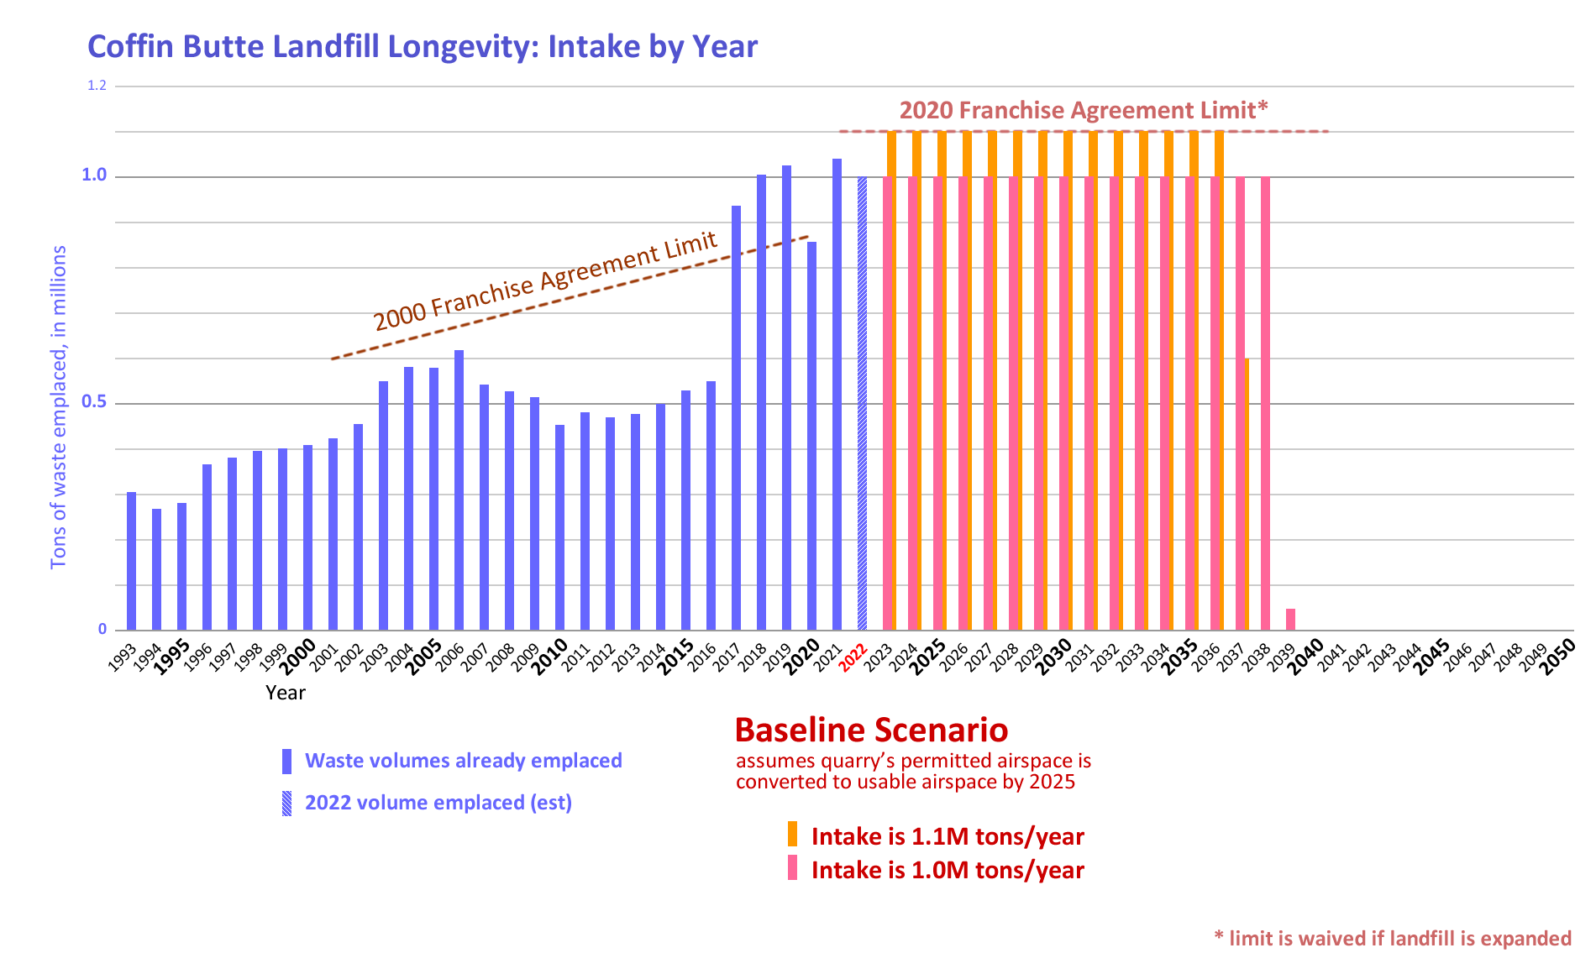
The subcommittee did not receive evidence regarding the landfill owner’s intent in this regard, or its ability.

Figure 3.C.2

“What if the franchisee cannot excavate all of the quarry?”

Scenarios built upon the Baseline: Quarry Levels
Roughly 2.7 million cubic yards of the landfill’s permitted airspace is currently unavailable because it is unexcavated rock. The landfill’s owner holds a surface mining permit for this rock, and franchises it to Knife River as a quarry. For the past few years Knife River has currently quarried the rock at a rate of roughly 150,000 cubic yards a year, so at a normal pace the airspace will not be fully available until the year 2040.

This poses a dilemma for the landfill’s owners, because the landfill is on track to fill its current cell in 3 years, when it will look to move operations into the quarry area. The landfill and the quarry cannot safely overlap their operations in the airspace. Ideally, the quarry would pre-excavate all the rock by year-end 2024, and the landfill would then prepare the quarry site for landfilling. Alternatively, the landfill could use a new permitted area (a landfill expansion) as a “bridge” to give the quarry more time to pre-excavate, but it seems unlikely that a landfill expansion could be (a) successful and (b) legally resolved in time to be useful.

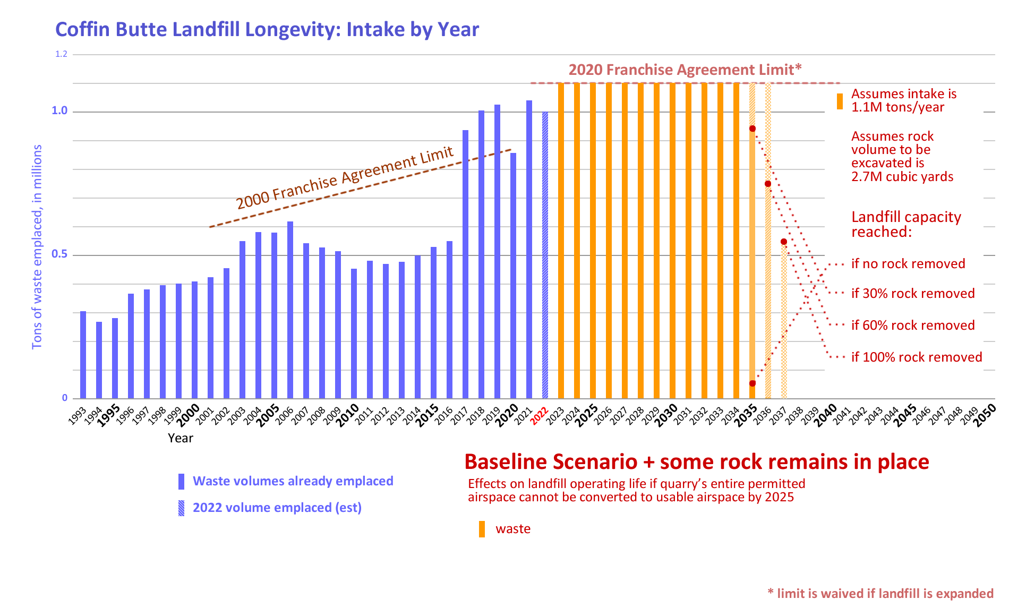
We do not currently know how much rock can be pre-excavated before landfilling operations move into the quarry airspace. We can display the possibility range graphically, in Figure 3.C.3.

Figure 3.C.3

“What if the franchisee obtains a permit to expand the landfill?”

Scenarios built upon the Baseline: Expansion(s)
The baseline scenario may only be fully realized in combination with a landfill expansion – to serve as a bridge landfilling site that allows time for the quarry airspace to be pre-excavated. The landfill owner has indicated that it will apply for such an expansion, likely in the first half of 2023. Almost certainly this expansion site would be the area south of Coffin Butte Road that is already zoned as Landfill Site; we can roughly estimate the size of this expansion airspace as 6M cubic yards.

This application may be followed by others, either to continue to act as bridges for quarry excavation or to take advantage of the removal of the intake cap, which happens once the first expansion is approved, according to the 2020 Franchise Agreement. Any expansion may close Coffin Butte Road or seek to rezone other areas around the landfill as Landfill Sites.

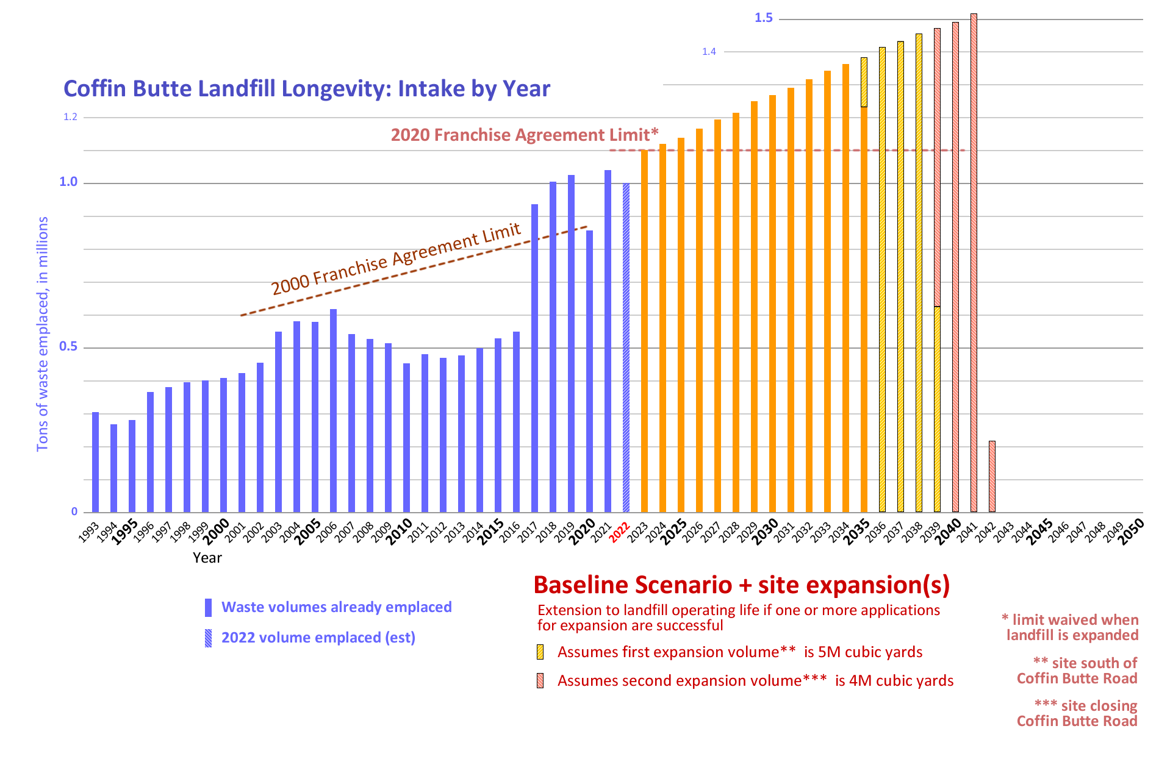
We can represent the effect this set of scenarios would have on baseline longevity, as Figure 3.C.4.

Figure 3.C.4

“What if the franchisee exceeds the 2020 Franchise Agreement limit?”

Scenarios built upon the Baseline: Intake Cap Disregarded
The 2020 Franchise Agreement limits the franchisee to a cap of 1.1M tons per year, but does not include any provisions for enforcement of that cap. There is historical precedent, however; as described earlier in Section 1.C, when the 2000 Franchise Agreement limit was exceeded, Benton County signed a Memorandum of Understanding that allowed the exceedance with fees per ton. There is contemporary precedent also, as the 2020 Franchise Agreement also specifies a fee-per-ton that would apply if the cap were contractually lifted when an expansion was approved.

This scenario represents the effect on landfill longevity if the franchisee disregards the intake limit specified in the 2020 Franchise Agreement and the County responds either with no action or with an accommodation agreement such as a per-ton surcharge.

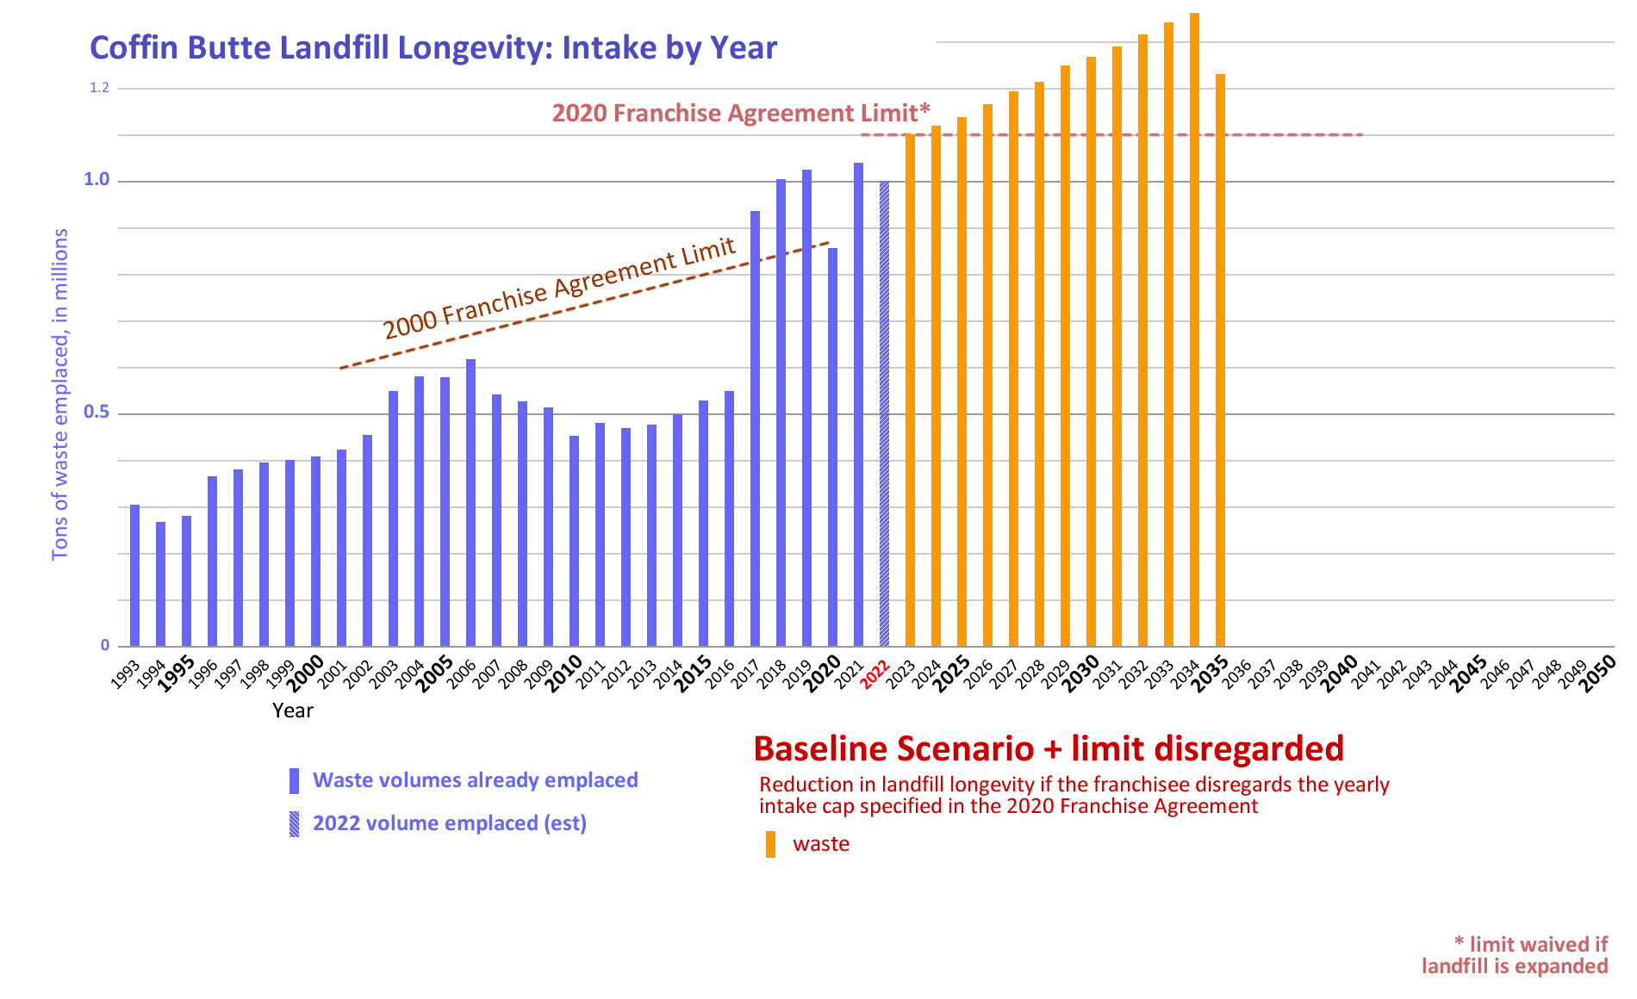
We can represent the effect this scenario would have on baseline longevity, as Figure 3.C.5.

Figure 3.C.5

Note: this scenario, coupled with possible excavation shortfalls in the quarry scenario or with debris flows from wildfires or other disasters, represents the shortest longevity of the landfill in our scenarios: landfill life of less than a dozen years.
“What if the factors which historically have acted on landfill intake are taken into account?”

Scenarios built upon the Baseline: Historical Variance
The baseline scenario is derived primarily from the annual intake the landfill owner and would like to achieve and maintain. In reality such stability occurs rarely if ever. Historically, the annual intake of a landfill is determined by many factors, many beyond the owner’s ability to control or to counteract.

The following graphic (Figure 3.5) shows variance due to (a) slow but steady demand by people to reduce their garbage disposal costs, (b) growing demand by people for less polluting alternatives to waste disposal, (c) growing population in the wasteshed, (d) competitive pressure from innovative alternatives to landfilling, (e) sudden spikes in intake due to wildfires, floods, and other climate-related disasters, and (f) pressure by the landfill owner to maintain intake via downward pricing and cost-cutting. These are all factors that have caused the intake rate to fluctuate in the past. These “human factors” are discussed more fully in Section 4.
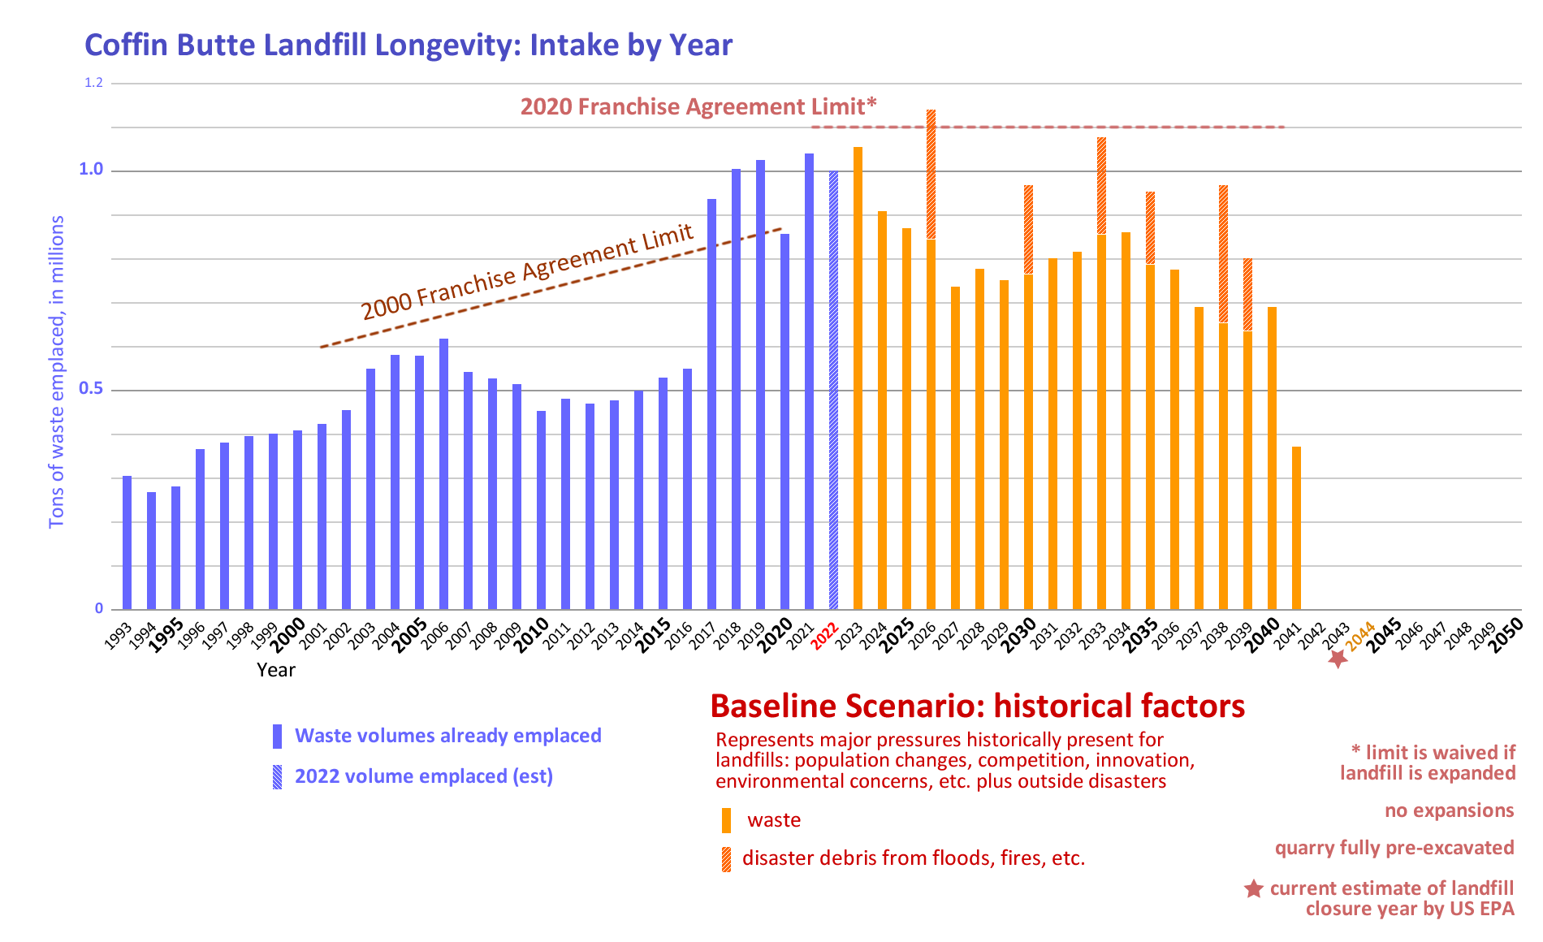

Figure 3.C.6

“What if landfill intake is affected by growing concerns about the climate crisis?”

Scenario built upon the Baseline: Climate Crisis Legislation
People all over the world are growing increasingly concerned about the threat the uncontrolled release of greenhouse gases poses to the ecosystems that human societies depend upon. In the United States, this fight is focused on the release of methane, a potent greenhouse gas. Landfills are major sources of greenhouse gas emissions, especially methane. In its Methane Emissions Reduction Plan, the US government is using all available tools to identify and reduce methane emissions from all major sources. The Inflation Reduction Act of 2022 prioritized curtailing methane pollution in the oil and gas industry sector, initiating a program that catalyzes pollution detection and offers incentives for reduction and imposes penalties for continued releases of methane into the atmosphere.

Since methane is not “destroyed” nor does it become carbon neutral, the best way to mitigate landfill methane is never to create it in the first place, i.e., to divert waste, especially organic waste, from ever entering a landfill. This is a fundamental logic when curtailing landfill methane.

Legislation.
In this scenario, methane-corrective measures similar to the ones currently imposed on the oil/gas industry are extended into the landfill industry. As is happening in the oil/gas industry, the measures focus on incentives to prevent methane from being emitted, but include penalties for methane pollution. This extension happens in the year 2024. As they are doing in the oil/gas industry, federal and state environmental agencies offer billions of dollars in incentives tailored to catalyze efforts that can curtail landfill methane. These incentives would attract companies and organizations with waste-reduction ideas to target the high-organic sector of the landfill’s intake (about a quarter of total intake mass) for diversion away from the landfill, and motivate the landfill operator to align with this diversion.

This scenario also encompasses “crossover” legislation that reduces methane-generating waste from entering the landfill, although that is not the primary aim of the legislation. This process has already begun: the 2023 Food Donation Improvement Act aims to prevent food from being wasted but also diverts food from the wastestream as a greenhouse gas reduction measure.

This scenario presents a national initiative designed to impact the landfill’s entire wasteshed. A representation of its effect is shown in Figure 3.C.7.

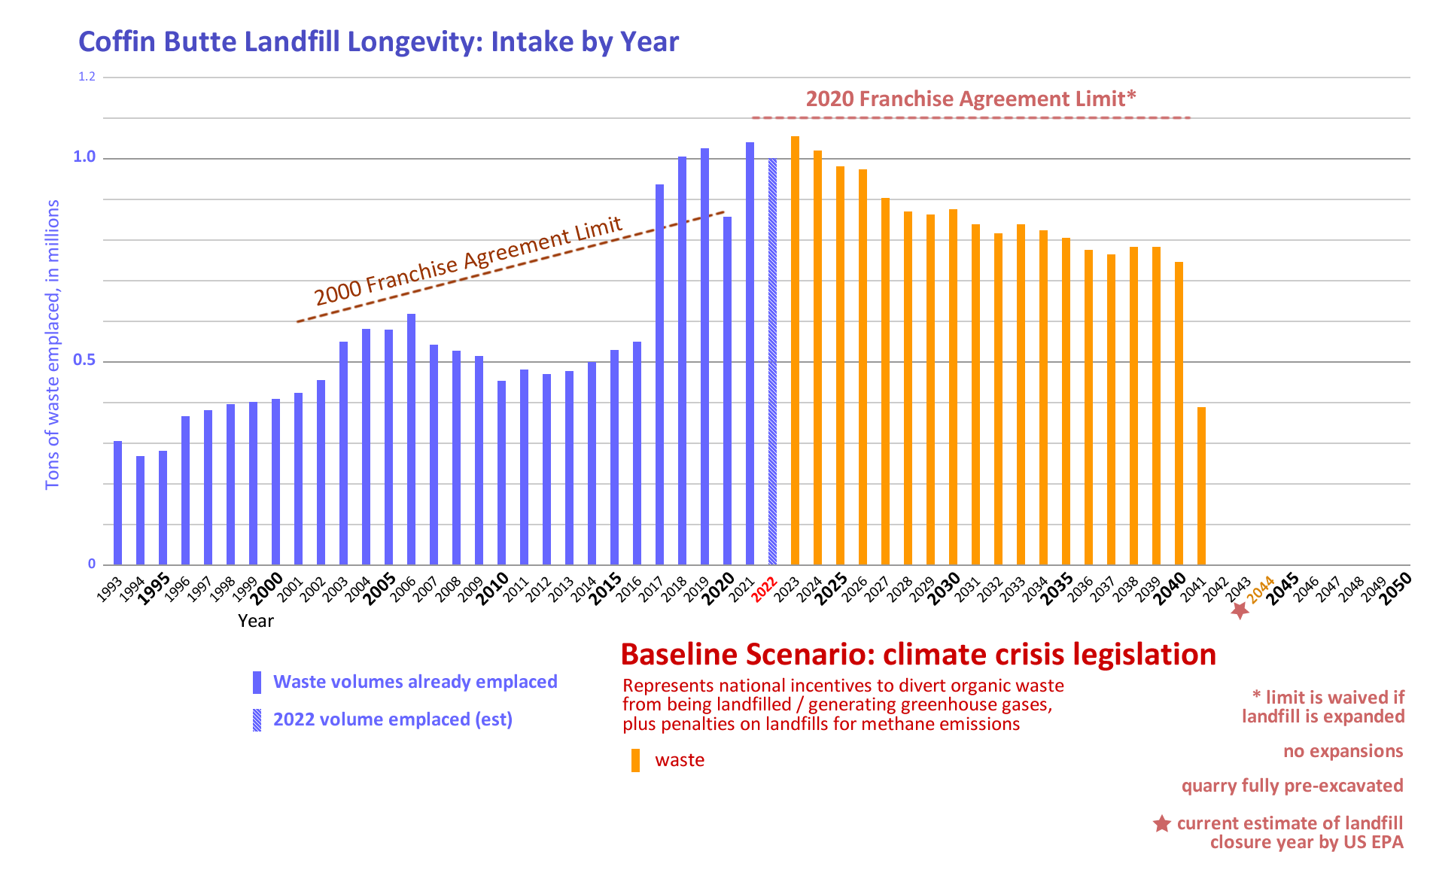
Figure 3.C.7

Conclusion: A Confluence of Factors – Findings and Recommendations

The subcommittee has generated a List of potential factors impacting site life; this list is not exhaustive and its characterizations are limited; we hope a more complete list and more detailed characterizations will come as Benton County prepares a Sustainable Materials Management Plan.
These factors are all relevant to understanding the possible longevity of Coffin Butte Landfill. Each factor has its own likelihood of being significant to landfill longevity and its own effect over time, and each joins with other factors to determine the actual longevity. These factors have been included to enable the reader to form a conception of the likely “possibility space” for the landfill’s operation from current day to its End Of Life.
The possibility space shows landfill closure as early as 2034 and as late as 2045. Within that range, the landfill’s 2021 Site Development Plan estimates the closure year to be 2039 and the EPA shows a closure year of 2044. The franchisee’s baseline projects a closure range of 2037-2039. The franchisee intends to keep intake rates as high as possible, as shown in their baseline projection. Intake-increasing factors such as population growth and debris from disasters may drive up intake rates and thus shorten landfill life within the range; intake reduction factors such as recycling and waste diversion, plus emerging factors such as extended producer responsibility (EPR) incentives and climate crisis legislation, may drive down intake rates and thus lengthen landfill life in the range and beyond.

- The subcommittee has generated a List of potential factors impacting site life; this list is not exhaustive and its characterizations are limited.
- Human factors are all relevant to understanding the possible longevity of Coffin Butte Landfill. Each factor has its own likelihood of being significant to landfill longevity and its own effect over time, and each joins with other factors to determine the actual longevity.
- The possibility space shows landfill closure as early as 2034 and as late as 2045. Closure outside of this date range is possible, but seen as less likely.
- Within the 2034-2045 range, the landfill’s 2021 Site Development Plan estimates the closure year to be 2039 and the EPA shows a closure year of 2044. The franchisee’s baseline projects a closure range of 2037-2039.
- The franchisee’s baseline projection of 2037-2039 is based upon an intention to keep intake rates as high as possible.
- Intake-increasing factors such as population growth and debris from disasters may drive up intake rates and thus shorten landfill life within the 2034-2045 range; intake reduction factors such as recycling and waste diversion, plus emerging factors such as extended producer responsibility (EPR) incentives and climate crisis legislation, may drive down intake rates and thus lengthen landfill life within the 2034-2045 range and beyond.

- The subcommittee has generated a List of potential factors impacting site life; this list is not exhaustive and its characterizations are limited.
- Human factors are all relevant to understanding the possible longevity of Coffin Butte Landfill. Each factor has its own likelihood of being significant to landfill longevity and its own effect over time, and each joins with other factors to determine the actual longevity.
- The possibility space shows landfill closure as early as 2034 and as late as 2045. Closure outside of this date range is possible, but seen as less likely.
- Within the 2034-2045 range, the landfill’s 2021 Site Development Plan estimates the closure year to be 2039 and the EPA shows a closure year of 2044. The franchisee’s baseline projects a closure range of 2037-2039.
- The franchisee’s baseline projection of 2037-2039 is based upon an intention to keep intake rates as high as possible.
- Intake-increasing factors such as population growth and debris from disasters may drive up intake rates and thus shorten landfill life within the 2034-2045 range; intake reduction factors such as recycling and waste diversion, plus emerging factors such as extended producer responsibility (EPR) incentives and climate crisis legislation, may drive down intake rates and thus lengthen landfill life within the 2034-2045 range and beyond.

The above section requested by Ken Eklund to replace the below section

The baseline scenario described in Part A, above, graphically displays the landfill’s longevity as shown in Figure 3.2, below:

Figure 3.2

This scenario is termed a baseline because it is a simple projection that more sophisticated scenarios can be built upon. As indicated in its Assumptions, this baseline scenario is not a “default future”; it is not realistic, in that it references itself only, has no supporting data, is aspirational, and does not incorporate outside factors. It is our baseline because it models the idealized parameters (and longevity) intended for the landfill by the landfill’s owner, which is: a steady annual intake of between 1M and 1.1M tons for the duration of the landfill’s 14.5-16 year site life (to 2037-2039).

Scenarios built upon the Baseline: Quarry Levels
Roughly 2.7 million cubic yards of the landfill’s permitted airspace is currently unavailable because it is unexcavated rock. The landfill’s owner holds a surface mining permit for this rock, and franchises it to Knife River as a quarry. For the past few years Knife River has currently quarried the rock at a rate of roughly 150,000 cubic yards a year, so at a normal pace the airspace will not be fully available until the year 2040.

This poses a dilemma for the landfill’s owners, because the landfill is on track to fill its current cell in 3 years, when it will look to move operations into the quarry area. The landfill and the quarry cannot safely overlap their operations in the airspace. Ideally, the quarry would pre-excavate all the rock by year-end 2024, and the landfill would then prepare the quarry site for landfilling. Alternatively, the landfill could use a new permitted area (a landfill expansion) as a “bridge” to give the quarry more time to pre-excavate, but it seems unlikely that a landfill expansion could be (a) successful and (b) legally resolved in time to be useful.

We do not currently know how much rock can be pre-excavated before landfilling operations move into the quarry airspace. We can display the possibility range graphically, in Figure 3.3.
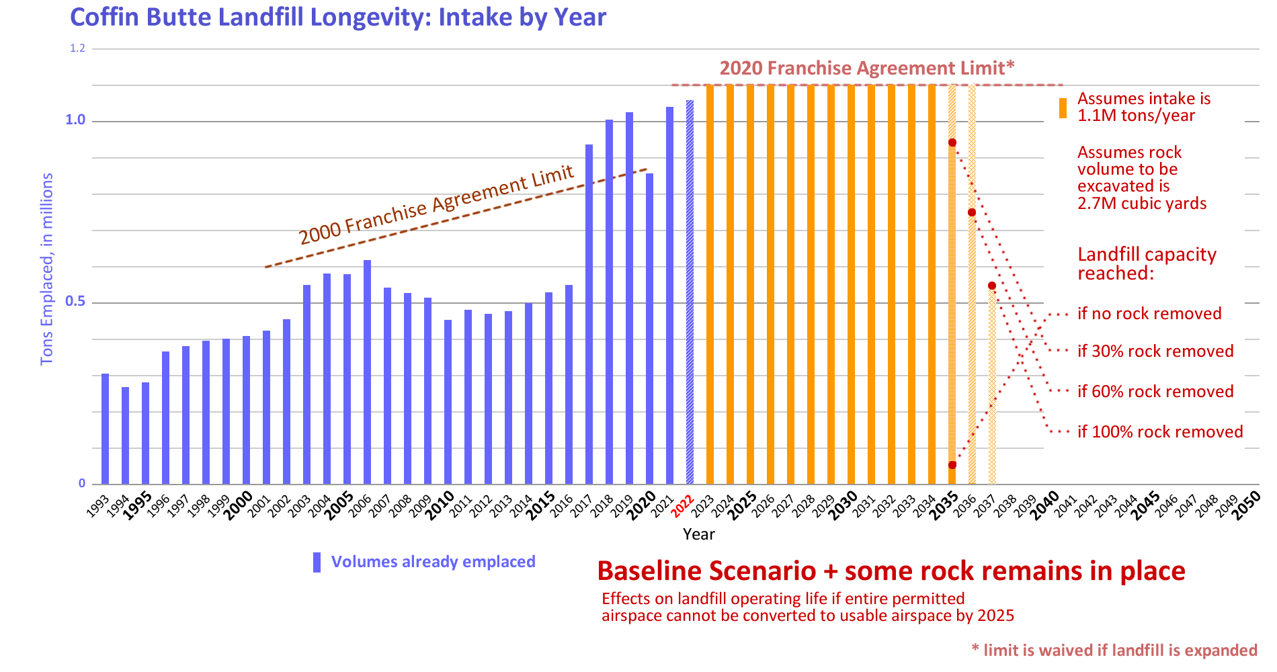
Figure 3.3

Scenarios built upon the Baseline: Water Table
A (currently unquantified) portion of the landfill’s permitted airspace seems to lie below the groundwater level, and it is unclear at this time whether or not Oregon DEQ regulations will allow this theoretical airspace to be used. if not permitted, actual permitted airspace would decrease and the lifespan of the landfill would shorten, in proportion to the volume affected.

Scenarios built upon the Baseline: Expansion(s)
Scenarios built upon the Baseline: Expansion(s)
The baseline scenario may only be fully realized in combination with a landfill expansion – to serve as a bridge landfilling site that allows time for the quarry airspace to be pre-excavated. The landfill owner has indicated that it will apply for such an expansion, likely in the first half of 2023. Almost certainly this expansion site would be the area south of Coffin Butte Road that is already zoned as Landfill Site; it’s unlikely that the expansion would involve the airspace over the road itself, as closing the road proved problematic in the 2021 expansion attempt. We can roughly estimate the size of this expansion airspace as 6M cubic yards.

This application may be followed by others, either to continue to act as bridges for quarry excavation or to take advantage of the removal of the intake cap, which happens once the first expansion is approved, according to the 2020 Franchise Agreement. These further expansions may close Coffin Butte Road or seek to rezone other areas around the landfill as Landfill Sites.

We can represent the effect this set of scenarios would have on baseline longevity, as Figure 3.4.
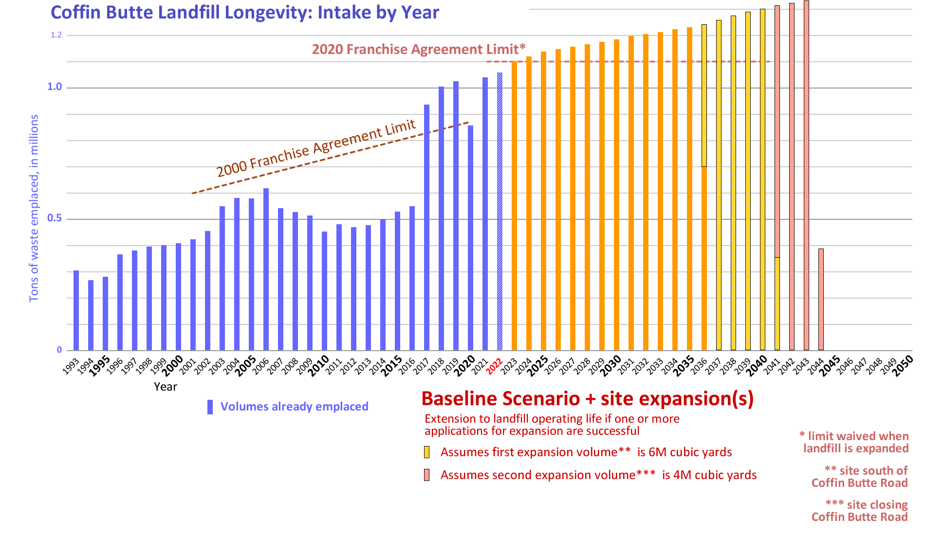
Figure 3.4

Scenarios built upon the Baseline: Historical Variance
Scenarios built upon the Baseline: Historical Variance
The baseline scenario is derived primarily from the annual intake the landfill owner has achieved and would like to maintain. In reality such stability occurs rarely if ever. Historically, the annual intake of a landfill is determined by many factors, many beyond the owner’s ability to control or to counteract by expanding the wasteshed.

The following graphic (Figure 3.5) shows variance due to (a) slow but steady demand by people to reduce their “tax” of garbage disposal costs, (b) growing demand by people for less polluting alternatives to waste disposal, (c) growing population in the wasteshed, (d) competitive pressure from innovative alternatives to landfilling, (e) sudden spikes in intake due to wildfires, floods, and other climate-related disasters, and (f) pressure by the landfill owner to maintain intake via downward pricing and cost-cutting. These “human factors” are discussed more fully in Section 4.

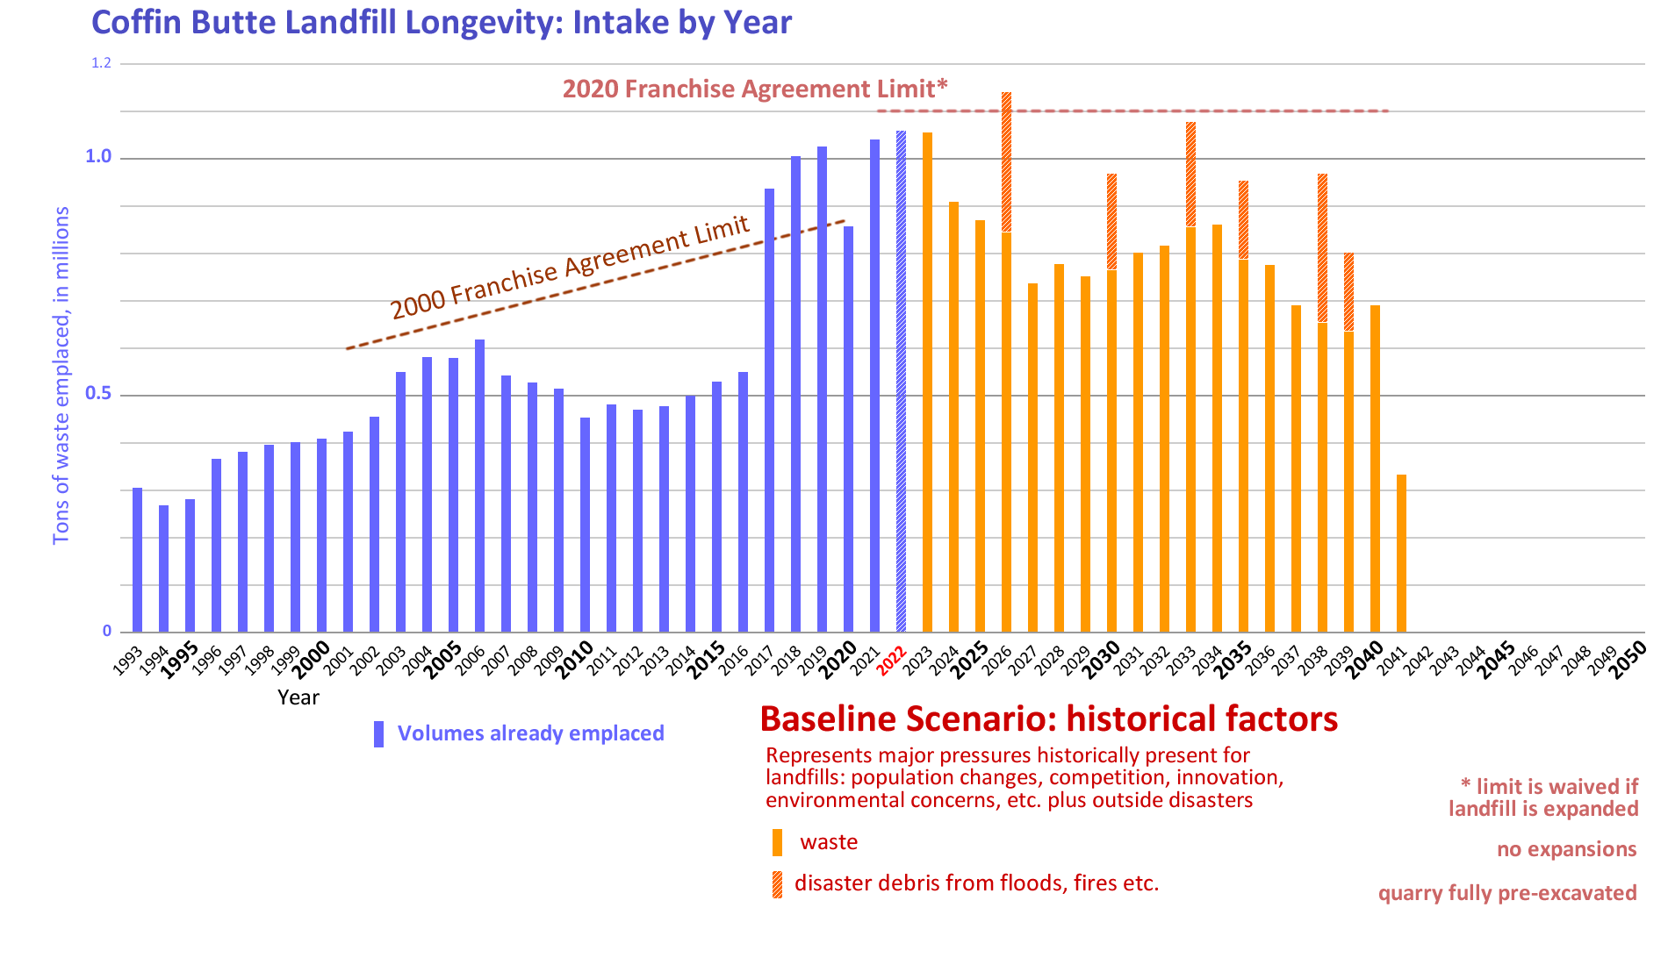
Figure 3.5

Scenarios built upon the Baseline: Climate Crisis Legislation/Legal Action/Activism
Scenarios built upon the Baseline: Climate Crisis Legislation/Legal Action/Activism
People all over the world are growing increasingly concerned about the threat the uncontrolled release of greenhouse gases poses to the ecosystems that human societies depend upon. In the United States, this fight is focused on the release of methane, a potent greenhouse gas. Landfills are major sources of greenhouse gas emissions, especially methane. In its Methane Emissions Reduction Plan, the US government is using all available tools to identify and reduce methane emissions from all major sources. The Inflation Reduction Act of 2022 prioritized curtailing methane pollution in the oil and gas industry sector, initiating a program that catalyzes pollution detection and offers incentives for reduction and imposes penalties for continued releases of methane into the atmosphere. At the same time, environmentally engaged citizens are suing governmental agencies, and investors are suing corporations, for failing to act responsibly on the climate crisis. These signals of change are discussed in Section 4.

Since methane is not “destroyed” nor does it become carbon neutral, the best way to mitigate landfill methane is never to create it in the first place, i.e., to divert waste, especially organic waste, from ever entering a landfill. This is a fundamental logic when curtailing landfill methane.

The preceding graphic (Figure 3.5) does not take into account these increasing pressures for action. The following graphic (Figure 3.6) shows one range of possible effects of these regulatory, legal, political and competitive pressures.

<graphic to come>

Figure 3.6

- Section 4: Human Factors Affecting Landfill Size/Capacity/ Longevity – Ken Eklund
Assessing Human Factors
Although the physical parameters of Coffin Butte Landfill play a role in its longevity (“operating life”), human factors drive the actual outcome, because they determine the inflow of material that fills up the landfill’s permitted volume (and shape that volume itself). Unlike the physical factors, human factors – by which we mean decisions and agreements such as business and legal obligations, legislation, enforcement, civic action and attitudes, technological advances, risk assessments and risk taking, individual and collective values and choices, and so on – have the power to shift the landfill’s operating life very quickly. Estimations of the operating life of the Coffin Butte Landfill necessarily rely on assessments and assumptions about the entire system that feeds waste to the landfill, and this wider system is created by, motivated by, operated by, and continuously being changed by human factors.

When mapping possible futures, experts use different methods to assess human factors than they do for physical factors. “Scenario planning” poses what if questions to anticipate future possibilities. “Futures signaling” looks for events that indicate coming trends or movements. Using these futurecasting methods is important because for many people, cognitive biases limit their view of the future to be a mere extension of the present, with only incremental changes, even though their actual experience is of a world in which radical and disruptive changes are occurring at an ever-faster rate. “Imagination training” can be a useful tool to be more successful at discerning these patterns of change change.

The Climate Change Imperative, and Methane
People all over the world are growing increasingly concerned about the threat the uncontrolled release of greenhouse gases poses to the ecosystems that human societies depend upon. The 27th Conference of the Parties to the United Nations Framework Convention on Climate Change (COP27) took place from 6 to 20 November this year, and hosted more than 100 Heads of State and Governments and over 35,000 participants who engaged in high-level meetings and key negotiations regarding climate action. UN Secretary-General António Guterres said that more needs to be done to drastically reduce emissions now. “The world still needs a giant leap on climate ambition… we can and must win this battle for our lives.” He urged the world not to relent “in the fight for climate justice and climate ambition.”

In the United States, this fight is focused on the release of methane, a potent greenhouse gas. The US is one of the world’s top 10 methane emitters, and methane emissions are a major contributor to climate change, “which is why President Biden is taking critical, commonsense steps at home to reduce methane across the economy.” Last year the US announced that it was joining with more than 100 world governments to meet a Global Methane Pledge and reduce the world’s methane emissions 30% from 2020 levels by 2030. Humans produce the bulk of methane pollution, and atmospheric concentrations of methane have been trending upward for more than a decade, with 2020 seeing the biggest one-year jump on record.

Through the 2021 Methane Emissions Reduction Plan, the US government is using all available tools – “commonsense regulations, catalytic financial incentives, transparency and disclosure of actionable data, and public and private partnerships – to identify and cost-effectively reduce methane emissions from all major sources.” As part of this Plan, in a carrot-and-stick manner, the EPA has begun to both catalyze multi-pronged action against, and assess penalties for, the release of methane into the atmosphere.

Landfills are major sources of greenhouse gas emissions. Landfilling inherently creates methane as a natural byproduct of the decomposition of organic material in landfills. Landfill gas is composed of roughly 50 percent methane (the primary component of natural gas), 50 percent carbon dioxide (CO₂) and a small amount of non-methane organic compounds. Methane and carbon dioxide are odorless; “landfill smell” is from the trace non-methane organic compounds.

In the past methane pollution has been difficult to quantify. For landfills, historically the EPA has relied on theoretical calculations to estimate pollution, but these mathematical models by definition produce estimates, not exact data – useful at a national level but less so at a per-landfill level. In response, other organizations have engineered their own models that are more useful for assessing emissions at a particular landfill. In recent years, focus has shifted to better direct measurement technologies for more accurate and transparent emissions reporting.

Using area measurement tools deployed on satellites, aircraft, and towers, the Environmental Defense Fund has shown that landfill outputs are generally higher than EPA calculations indicate. Carbon-Mapper, a joint public-private enterprise, focuses on identifying super-emitters, because a previous flyover project across California discovered that only 1% of sites produced 50% of methane emissions, and the largest emissions were from landfills. Carbon-Mapper plans to launch two satellites in 2023, building to a suite of 20 satellites eventually; these will join other systems such as Kayrros, a French company, and MethaneSAT, a subsidiary of the EDF.

These developments all signal a changed operating environment for Coffin Butte Landfill, one in which its greenhouse gas emissions move from being unknown and unexamined to being an open number impacting waste flows, operating costs, regulatory fines, corporate investment levels, public action, and more. Coffin Butte Landfill may be a particular target for negative effects, because its wet environment converts waste to methane quickly. This section details several Scenarios which explore these impacts upon the landfill’s anticipated operating life.

It’s important to note here that landfill methane poses a lesser-of-evils situation. The best-case environmental outcome for methane, once it is generated from municipal solid waste, is for it to oxidize into carbon dioxide, i.e., for it to transition from a quick-acting high-impact greenhouse gas into a slower-acting, durable greenhouse gas. Methane is not “destroyed” nor does it become carbon neutral. Therefore, the best way to mitigate landfill methane is never to create it in the first place, i.e., to divert waste, especially organic waste, from ever entering a landfill. This is a fundamental logic at work with landfill methane now and into the future.

Scenarios
A. Climate Crisis Legislation
Scenario: the methane-corrective measures imposed on the oil/gas industry are extended into the landfill industry, focusing on incentives to prevent methane from being emitted but including penalties for methane pollution. This extension happens in the year 2024.

In this scenario, as they are doing in the oil/gas industry, federal and state environmental agencies offer billions of dollars in incentives tailored to catalyze efforts that can curtail landfill methane.

In this scenario, federal and state environmental agencies announce and implement financial penalties (fines) for methane release to the atmosphere. As is currently happening in the oil/gas industry, these penalties are eased in over a four-year period, and cap at a rate around $1550 per metric ton in 2022 dollars.

In general, the effect of this carrot + stick scenario on Coffin Butte Landfill’s operating life would be to lengthen it. The incentives would attract recyclers and other entities to target the high-organic sector of the landfill’s intake (about a quarter of total intake mass) for diversion away from the landfill, and the penalties would bring the landfill operator into alignment with this diversion (and reduction of profit). This would be a sea change in the wasteflow, creating knock-on opportunities to create circular economies for other types of waste, motivated by environmental concerns, economic efficiencies, and other reasons.

It’s also possible that this scenario would shorten the operating life of Coffin Butte Landfill, even precipitously, if the prospective penalties for incoming waste (plus the penalties for methane emissions from waste already emplaced) cut unacceptably into the profit schema of the landfill owner. The likelihood of this eventuality depends upon the actual methane output of the landfill, which is currently undocumented.

The signal for this scenario is strong, because it is based upon the stated goals of the US government, its commitments to climate action to the world, and goals and provisions already in place with the US 2021 Methane Emissions Reduction Plan.

Another legislative scenario to mention briefly, related to the climate crisis: efforts to limit atmospheric carbon widen to non-methane sources in the US, in the form of a carbon tax and/or subsidies for rail electrification. This scenario would disrupt the current operations in the Coffin Butte wasteshed, by establishing new incentives to transport waste by rail rather than truck. This scenario is likely to extend the operating life of Coffin Butte Landfill, which has no rail connection and depends on trucking for its inflow. If entities can transport waste more economically by rail to cleaner landfills or to regional waste reclamation centers, that would cut inflow to Coffin Butte Landfill.

B. Climate Crisis Legal and Shareholder Action
Scenario: Environmentally engaged citizens sue governmental agencies (and investors sue corporations) for failing to act on the climate crisis. These lawsuits compel action to reduce emissions of greenhouse gases, which in turn boost efforts to divert material, especially food and other high organic waste, from being landfilled at Coffin Butte Landfill. In this scenario, these lawsuits have the potential to occur across the wasteshed.

Signals for this scenario set exist in plenty. Groups of environmentally engaged citizens are already pursuing lawsuits against states and nations; such cases appear regularly in the news as current ones wind their way through the courts and new ones are filed. Climate activism is already widespread in Oregon and the landfill’s wasteshed includes areas disposed politically toward this kind of legal action. Benton County is more likely than most to be targeted for this kind of lawsuit, as its population generally prioritizes environmental concerns and the County has not shown concern over greenhouse gas emissions in its administration of Coffin Butte Landfill.
“I started looking at the world through a new lens recently — when my older daughter gave me the incredible news that I’ll become a grandfather next year… I can sum up the solution to climate change: We need to eliminate global emissions of greenhouse gases by 2050… We need to revolutionize the entire physical economy… If we don’t get to net-zero emissions, our grandchildren will grow up in a world that is dramatically worse off.” The grandfather-to-be is Bill Gates, a major shareholder in Republic Services’ stock.
This scenario would further extend the operating life of the landfill if methane studies show that Coffin Butte Landfill is a worse polluter than alternative landfills in drier climates (if Coffin Butte Landfill converts waste to methane more quickly, for example). The legal action would then not only divert high-organic material out of the wastestream, but divert unsorted waste away from Coffin Butte Landfill to less-polluting alternatives.

C. Climate Crisis Environmental Activism
Scenario: Environmental activists accelerate their efforts to increase accountability for, and limit waste intake at, Coffin Butte Landfill. These efforts consist mostly of expansion to the current level of civic engagement but also branch out as protests and other direct action when civic engagement cannot produce the depth and velocity of change required for environmental protection.

This scenario is similar to, and operates in tandem with, the “legal action” scenario, and has a similar effect of reducing intake at the landfill. Activism happens more quickly however, so the primary impact of this scenario is as an across-the-board accelerant and forcer for all the environmentally motivated changes being discussed in this section.

Signals for environmental activism’s impact on the operating life of Coffin Butte Landfill are very strong. Environmental activism has already caused the single most impactful event on the operating life of Coffin Butte Landfill in its history: activists stopped the expansion of the Riverbend Landfill in Yamhill County, which effectively doubled trash intake at Coffin Butte Landfill to its current high level. Local activism is why the County has assembled its Workgroup studying the future of solid waste management in Benton County, and local activists feature prominently in the work done by the Workgroup so far.

D. Climate Crisis Effects Upon Landfill Operating Life
Scenarios: effects of the climate crisis itself circle back to affect the operating life of Coffin Butte Landfill, by increasing the incidence of wildfires, floods, droughts, and other disruptions to the landfill’s extensive infrastructure; by causing rapid and novel shifts in population migrations and attitudes; by posing threats to the landfill’s operational status itself.

Signals for this set of scenarios are strong. Worldwide, the number and severity of climate events and disasters is growing, made more extreme by climate-crisis effects. Locally, in 2020 the Beachie Creek–Lionshead wildfire generated about a third of a million tons of debris for Coffin Butte Landfill. The region continues to slide into multi-year drought, which extends the fire season in an area already at risk with high forest fuel loads. The Willamette Valley now has a regular “smoke season.” Rain events are growing in severity, increasing chances for flood events in the landfill’s wasteshed and on the landfill itself. As a creator of flammable methane, the landfill has clear potential for a major fire event; it has caught fire in the past, which on one occasion called for a large fire response and took over 24 hours to bring under control.

Despite these trends, the Pacific Northwest is seen as a haven for those elsewhere who have been even more severely impacted by heat, fire, flood and other disasters.

In the main, climate crisis events are likely to shorten the landfill’s operating life. Fires and flooding have the potential to generate debris flows that will consume capacity, as would a population boost from climate refugees relocating into the wasteshed.

The most extreme scenarios shorten the landfill’s operating life precipitously. The landfill itself could have a flooding event, where leachate cannot be pumped out fast enough or overflows its collection ponds for example, with effects unknown upon the landfill’s ability to continue operations. Wildfire is a clear existential threat, as landfills are full of both incendiary methane and flammable material; landfill fires can burn deep, are difficult to fight and have been known to burn for years and take over a hundred million dollars to extinguish.

These events concatenate: a storm event, for example, might knock out power to the landfill for an extended period, which then leads to a flood event as pumps cannot operate. An earthquake could cause both a power outage, which collapses the landfill’s ability to operate its methane extraction system, and multiple wildfires, which threaten to ignite the uncontrolled methane. In such scenarios, the landfill is not a direct threat to human life and thus not a priority for firefighters or other emergency action, so any incident can snowball.

E. Longevity: Post-Operational Costs
Climate legislation, activism, crisis events, and so on are all increasing the burden of monitoring and maintaining public safety for the decades required after the landfill ceases operations. It’s estimated that the landfill will continue to produce significant amounts of methane for 20 years after it closes, for example. If that methane is incurring penalties, who will be paying them? If trees need to be prevented from growing on the landfill cover, who will be performing that maintenance? And so on, through a growing list of like questions.

Scenario: As a clearer picture of the landfill’s post-operational burden emerges, it sparks action to cut the landfill’s waste intake. This effort may be initiated by the County, in an effort to both reduce the landfill’s pollution impacts and to put off the day when responsibility for the landfill is transferred to the County; it may be initiated by citizens, in an effort to both reduce the pollution impacts and to delay transition to another waste management scheme; it may be initiated by the landfill owner, in an effort to delay incurring expensive post-operation environmental mitigations, and/or to keep alive the legal option to file for expansion.

Signals for this scenario include the current litigation at Riverbend Landfill in Yamhill County, where the landfill owner is trying to avoid closing the landfill by taking in a minimal amount of trash per year, and county citizens are suing to force the landfill to close.

F. Unforeseen Novel Effects
The scenarios listed above have signals that are easy to discern, and they manifest in more or less familiar ways. The level of change at work here, however, signals the strong possibility for novel and unforeseen effects, especially concatenating ones. In the same way that COVID manifested itself in a myriad of ways that were difficult to anticipate, the climate crisis is causing changes with ripple effects that have yet to become apparent.

These effects inject (more) uncertainty into the agreements and infrastructure of the landfill’s wasteshed, which in turn steers the entities in the wasteshed toward reducing their waste flows and increasing the resilience of their waste management by seeking other options. The unforeseen effects of climate change are likely to increase the landfill’s operating life.

G. Contractual Obligations
From day to day the wasteflow to Coffin Butte Landfill is governed by business contracts that Republic Services holds with various entities; the landfill’s wasteshed is defined and redefined by these contracts. Republic Services will not provide detail about these contracts, citing their proprietary nature, so the wasteflow’s net effect upon the operating life of the landfill is undocumented.

Imagination Training
When thinking about the future, it’s common for people to manifest a cognitive bias toward the status quo, to think the future is settled as an extension of the present. This bias can manifest itself even when change is clearly underway. To counteract this bias, it’s useful to require the arguments FOR the continuation of the status quo (rather than just accepting it as being unquestioningly able to continue).

To refute the idea that measures to prevent methane leaks will be extended from the oil/gas industry to the landfill industry, for example, would require a line of reasoning as to why those measures wouldn’t be extended into the landfill industry (which is known to leak methane).

Another example: minimizing the role of environmental activism (as a human factor in the landfill’s operating life) would require a line of reasoning as to why such activism will cease impacting the state’s landfilling ecosystem or will not continue to grow at its current pace.

Imagination training is also useful in exposing areas where data still holds sway, even though it is now known to be limited or obsolete, i.e., where an old idea perseveres purely through momentum or inertia. An example would be the methane emissions level at Coffin Butte Landfill: to persist in relying on an obsolete EPA estimate would require a line of reasoning as to why that estimate should hold sway over modern direct measurements.

Determining Landfill Longevity - Ken Eklund
< summary of human factors to come >
< graphic to come >

We cannot predict the outcome or impact of every scenario
https://www.pdx.edu/population-research/sites/g/files/znldhr3261/files/2021-06/Final_Report_Benton.pdf
https://www.washingtonpost.com/business/americas-food-waste-problem-is-a-hunger-solution-in-disguise/2023/01/06/a6f5ba22-8dbe-11ed-b86a-2e3a77336b8e_story.html
https://www.wastetodaymagazine.com/news/oregon-signs-extended-producer-responsibility-law-packaging/
https://www.wastetodaymagazine.com/news/oregon-signs-extended-producer-responsibility-law-packaging/
Oregon's consumption-based greenhouse gas emissions in 2015
https://www.whitehouse.gov/wp-content/uploads/2021/11/US-Methane-Emissions-Reduction-Action-Plan-1.pdf
https://www.washingtonpost.com/business/americas-food-waste-problem-is-a-hunger-solution-in-disguise/2023/01/06/a6f5ba22-8dbe-11ed-b86a-2e3a77336b8e_story.html
https://www.pdx.edu/population-research/sites/g/files/znldhr3261/files/2021-06/Final_Report_Benton.pdf
Derived from Knife River testimony before the Benton County Planning Commission, November 2021.
Derived from Knife River testimony before the Benton County Planning Commission, November 2021.
Closure outside of this date range is possible, but seen as less likely
Endnotes to come.
Endnotes to come…

