Benton County Talks Trash Workgroup Report
1-3-23 Rough Draft
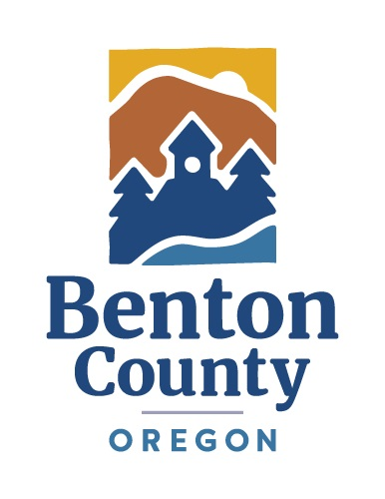

TABLE OF CONTENTS
Letter of Transmittal
Executive Summary
Acknowledgments
I. Process Background and Context
a. Context
b. Membership
c. Charter
1. Scope & Charge
2. Process for Workgroup Recommendations
II. Project Website and Workplans
- Project Website
- Initial Project Workplan
- Updated Project Workplan
- Final Project Workplan
III. Workgroup Meetings Topics and Tours
- Meeting 1
- Meeting 2
- Landfill Tour
- Neighborhood Tour
- Meeting 3
- Meeting 4
- Meeting 5 & Open House
- Meeting 6
- Meeting 7
- Meeting 8
- Meeting 9
IV. Subcommittees
- Landfill Size/Capacity/Longevity
- Past Land Use Application Conditions
- Sustainable Materials Management Plan
- Legal Issues & Land use Review
- Community Education & Public Involvement
V. Key Workgroup Findings & Recommendations
History of Coffin Butte
SECTION A: Landfill Size/Capacity/Longevity
SECTION B: Past Land Use Application Conditions
SECTION C: Sustainable Materials Management Plan (SMMP)
SECTION D: Legal issues and Land use Review
Final Polling
Last Meeting Transcript
[List Member statements in Alpha Order]
VI. Public Outreach and Process Reflections
a. Public Outreach
b. Member Process Evaluation Summary
c. Facilitator Process Reflections
VII. Conclusion
VIII. Appendix
a. Meeting Summary and Open House Topics
b. _______________
c. _______________
etc.
Report
Letter of Transmittal
March ____, 2023

To: Benton County Board of Commissioners,
From: BCTT though Sam Imperati, Facilitator .
RE: BCTT Workgroup Report

Please accept this final report, which summarizes the above process.

The Benton County Board of Commissioners (BOC) hired ICMresolutions to facilitate a Workgroup process for findings and recommendations for future Conditional Use Permits (CUP) and a Sustainable Materials management Plan (SMMP).
To accomplish this, the Board appointed Workgroup members that were representative of community voices. We then organized the Charter elements into different categories which later became Subcommittees. The Workgroup process began on September 8, 2022, and ended March ______, 2023, with the submission of this report. During that time, we conducted nine Workgroup meeting to address the following topics:

Our role was to facilitate these meetings, organize information, help develop recommendations, and produce this approved report. Our "client" was _________. At the final Workgroup meeting on March 16, 2023, the Workgroup recommended a series of _______________________. The results of that meeting can be found in section _____ of this report.

Thank you for the opportunity to support this important project.
Respectfully Submitted

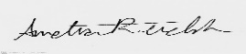
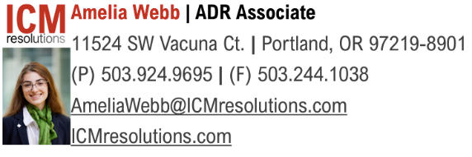
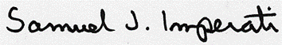
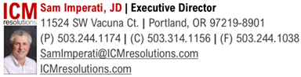

Executive Summary
Benton County’s “Benton County Talks Trash” Workgroup met nine times between September 8, 2022, and March 16, 2023. All Workgroup meetings were open to the public, and the project hosted an open house on November 17, 2022, after the fifth Workgroup meeting. Throughout the process ___#__ press releases were sent out and notifications for each Workgroup meeting went to ______, ____, and _______ channels. Recordings of the Workgroup meetings are available here, as well as meeting minutes and summaries.

During its process, the Workgroup created five Subcommittees to take on various parts of the Charter Elements. Information on the Subcommittee’s work product can be found on page _____ of this report, and recordings of the Subcommittee meetings are available here.

The Workgroup’s findings and recommendations will be provided to the Board of Commissioners on March ____, 2023, for their consideration. A summary of these findings and recommendations follows:

- Major Findings

- Major Recommendations
Acknowledgments

Board of Commissioners
Nancy Wyse – Chair
Pat Malone
Xan Augerot

Workgroup Members

Voting Members
Brandon Bates
Catherine Biscoe
Christopher McMorran
Chuck Gilbert
Ed Piteria
Elizabeth (Liz) Irish
John Deuel
Kathryn Duvall
Louisa Shelby
Marge Popp
Mary Parmigiani
Russ Knocke
Ryan McAlister
Shawn Edmonds

Non-Voting / Ex-Officio Members
Audrey O’Brian
Brian May
Daniel Redick
Sean McGuire
Shane Sanderson

Alternates
Andrew Johnson
Ginger Rough
Jen Brown
Julie Jackson

Previous Members
Brian Fuller
Joel Geier
Nancy Whitcomb
Scott Kruger

Project Team at Benton County
Cory Grogan
Daniel Redick
Darren Nichols
Greg Verret
Inga Williams
JonnaVe Stokes
Linda Ray
Sean McGuire

Facilitation Team
Sam Imperati, Facilitator, Institute for Conflict Management, Inc.
Amelia Webb, Associate Facilitator, Institute for Conflict Management, Inc

Project Website
https://www.co.benton.or.us/cd/page/solid-waste-process-work-group

How to read this document
For a general overview of the process and key recommendations, please see the Executive Summary (page ___). For more detail, please read the body of the report.

I. Process Background
a. Context
Before the formation of the “Benton County Talks Trash” (BCTT) workgroup, the contracted with Oregon Consensus to conduct a process assessment with the following Scope:
Benton County and key stakeholders seek assistance identifying and implementing a constructive path forward relating to sustainable materials management and the future of solid waste disposal in the Mid-Willamette Valley, including at the Coffin Butte regional landfill. Following a [December 7, 2021] Benton County Planning Commission denial of a proposed conditional use permit to expand the landfill, key participants recognize that a constructive path forward could benefit from the assistance of a third-party facilitator. Key stakeholders believe that an objective assessment of the situation, conducted by an impartial third party, would be a good first step. (Emphasis added.)
Based on this original Scope, the County asked Oregon Consensus to complete a third-party situational assessment. The Benton County Solid Waste Situational Assessment Report (Assessment Report) can be found here. The BOC accepted the Report during its July 19, 2022 meeting and approved funding for the process at its July 26, 2022 meeting.
Subsequently, on August 23, 2022 the Board approved a Charter for the BCTT workgroup, which can be found here.
- Membership
There are two categories: a) Polling Member; and b) Ex Officio Member. Polling Members have full rights of participation and “polling.” Ex Officio Members are “non-polling” information sources. Each could bring technical resources to the meetings. The technical resources could be used to participate in the discussions with permission of the Facilitator after a WORKGROUP discussion on the advantages and disadvantages surrounding their participation.

Each member was allowed to assign one WORGROUP alternate for the process. That person was required to have full authority to represent their Organization/Interest Group. If the alternate was attending, the primary member was required to provide written notice to Facilitator at least 72 hours in advance of a meeting’s start time.

Original Membership - Provided in the Charter

Organization/Interest Group | WORKGROUP Member | Polling | Ex Officio | Charge
SWAC/DSAC | Joel Geier | X |  | All
SWAC/DSAC | Marge Popp | X |  | All
Planning Commission | Nancy Whitcombe | X |  | All
Planning Commission | Elizabeth Irish | X |  | All
Republic: National | Russ Knocke | X |  | All but C
Republic: Local | Shawn Edmonds | X |  | All but C
Public | Brandon Bates | X |  | All
Public | John Deuel | X |  | All
Public | Kathryn Duvall | X |  | All
Public | Christopher McMorran | X |  | All
Public | Ryan McAlister | X |  | All
Public | Mary Parmigiani | X |  | All
Public | Ed Pitera | X |  | All
Public | Louisa Shelby | X |  | All
DEQ | Brian Fuller |  | X | All but D
Neighboring Jurisdiction | Marion County: Administrator Designee |  | X | Only C
Neighboring Jurisdiction | Linn County: Administrator Designee |  | X | Only C
Benton County Staff | Daniel Redick |  | X | All
Benton County Staff | Scott Kruger |  | X | All

Membership at the End of the Process

Organization/Interest Group | WORKGROUP Member | Polling | Ex Officio | Charge
SWAC/DSAC | Chuck Gilbert | X |  | All
SWAC/DSAC | Marge Popp | X |  | All
Planning Commission | Elizabeth Irish | X |  | All
Planning Commission | _____________ | X |  | All
Republic: National | Russ Knocke  ALT: Ginger Rough | X |  | All but C
Republic: Local | Shawn Edmonds  ALT: Julie Jackson | X |  | All but C
Public | John Deuel | X |  | All
Public | Kathryn Duvall | X |  | All
Public | Christopher McMorran | X |  | All
Public | Ryan McAlister | X |  | All
Public | Mary Parmigiani | X |  | All
Public | Ed Pitera | X |  | All
Public | Louisa Shelby | X |  | All
Public | Catherine Biscoe | X |  | All
DEQ | Audrey O’Brien |  | X | All but D
Marion County | Brian May  ALT: Andrew Jonson |  | X | Only C
Linn County | Shane Sanderson |  | X | Only C
Benton County Staff | Daniel Redick |  | X | All
Benton County Staff | Sean McGuire  ALT: Jen Brown |  | X | All

c. Charter
1. Scope & Charge
This was a “bridge” process between past events and next steps. The process was designed to reset the current dynamics with the development of “common understandings” and recommended protocols for the future substantive consideration of the solid waste issues.

This Workgroup is not a decision-making body. It is a recommendation-making group with the following Scope. (See, Assessment Report for details.) The recommendations are not binding on decision makers in any subsequent land use review, but will help inform all parties going into a review process.

The WORKGROUP, with concurrence of the County staff, prioritized the following topics.

- Develop Common Understandings to form the basis of the work.
- Clarifying existing criteria and information requirements for the land use review process for any proposed landfill expansion.
- Scope the necessary tasks to start a Long-Term Sustainable Materials Management Plan process.
- Provide input on additional topics raised in the Assessment Report:
- Consider creating a public-facing document and community education campaign on these topics.

2. Process for Workgroup Recommendations
The Facilitator assisted the WORKGROUP and its members in identifying objectives, addressing the diversity of perspectives, and developing substantive, practical recommendations. The WORKGROUP strove for and used a “consensus” recommendation-making approach to determine their level of agreement on proposals. This allowed members to distinguish underlying values, interests, and concerns with a goal of developing widely accepted solutions.
Consensus does not mean 100% agreement on each part of every issue, but rather support for a decision, “taken as a whole.” This means that a member may poll to support a consensus proposal even though they would prefer to have it modified in some manner to give it their full support. Consensus is a process of “give and take,” of finding common ground and developing creative solutions in a way that everyone can support. Consensus is reached if all members support an idea or can say, “I can live with that.”
When developing recommendations, the WORKGROUP addressed each issue individually, and in various combinations. It decided it wanted to make packaged or individual recommendations at the end of the process.
“1-2-3” Consensus Polling: The Facilitator assisted the WORKGROUP in articulating points of agreement, as well as articulating concerns that require further exploration. It used a “Consensus Polling” procedure for assessing the group’s opinion and adjusting proposals. In “Consensus Polling,” the Facilitator articulates the proposal. Each voting member then offers “one,” “two,” or “three,” reflecting the following:
    - “One” indicates full support for the proposal as stated.
    - “Two” indicates that the participant agrees with the proposal as stated but would prefer to have it modified in some manner to give it full support. Nevertheless, the member will support the consensus even if his/her suggested modifications are not supported by the rest of the group because the proposal is worthy of general support, as written.
    - “Three” indicates refusal to support the proposal as stated.
The Facilitator repeats the consensus voting process as reasonably practical and as time allows to assist the group in achieving consensus regarding a particular recommendation, so that all Polling Members are voting “one” or “two.” The results are noted in the WORKGROUP Report.
No Consensus – Majority and Minority Recommendations: If a consensus on an issue is not likely, as determined by the Facilitator, the poll results for the options considered will be presented to the BOC.
Summary of WORKGROUP Recommendations: The meeting summaries serve as the record of the WORKGROUP recommendations as supplemented by the addition of Polling Member statements who elect to submit additional information by the deadline established. The Facilitator packaged all this information into the WORKGROUP’S report to the BOC.

II. Project Website and Workplans
- Project Website: Link

- Initial Project Workplan: (Charter)

Meeting One: 9/8/22
- Introductions
- Review of Charter with Process Overview
- Member Comments
- Charge A: Discuss Common Understandings document draft
- Next Steps and Homework
- Meeting Evaluation
Meeting Two: 9/15/22
- Charge A continued: Develop Common Understandings
- Coffin Butte Tour
- Next Steps and Homework
Meeting Three: 10/6/22
- Charge B: Clarifying existing criteria and information requirements for the land use review process for any proposed landfill expansion
- Next Steps and Homework
Meeting Four: 10/27/22
- Charge B continued: Clarifying existing criteria and information requirements for the land use review process for any proposed landfill expansion
- Next Steps and Homework
- Mid-Process Evaluation
Meeting Five: 11/3/22
- Charge B continued, and Charge C: Scope the necessary tasks to start a Long-Term Sustainable Materials Management Plan process
- Next Steps and Homework
Meeting Six: 11/17/22
- Provide input on Charges D and E: Additional Topics
  - Hauling Reopening
  - Roles/Responsibilities
  - Timeline for code changes
  - Consider creating a public-facing document and community education campaign on these topics
- Authorize Draft to SWAC/DSAC and Planning Commission for comment
- Next Steps and Homework
Meeting Seven: 12/1/22
- Review SWAC/DSAC and Planning Commission Feedback
- Edit Draft Report
- Next Steps and Homework
Meeting Eight: 12/15/22
- Finalize Report to BOC
- Next Steps: The BOC is expected to consider the findings and recommendations in January 2023.
- Process Evaluation
- Celebration!

- Updated Workplan: (10/27/2022)
Subcommittee  Meetings  10/19 through 10/25 | 10/27/22 Meeting Four  Major Topics | Subcommittee  Meetings  10/31 through 11/9 | 11/17/22 Meeting Five Major Topics  and  Public Open House | Subcommittee  Meetings  11/21 through 12/7 | 12/15/22 Meeting Six  Major Topics
Staff organizes existing documents by subcommittee  One, 1.5-hour Subcommittee Kickoff Meeting  Specific Dates Pending Doodle Poll Results | - Four Subcommittee Reports  - SMMP Goals: Vision 2040  - Local Jurisdictions Discuss Charge C. SMMP and Charge E. Public Education Campaign |  | 1) Four Subcommittee Reports  2) Introduce Charge D and Create Subcommittee:  a) Scope tasks to Plan Hauling Reopener  b) SWAC/DSAC Role Clarity and PC/BOC Criteria Use  c) Code Change Timeline  3) Introduce Charge E and Create Subcommittee: Public-Facing Document and Community Education Campaign  4) Open House – Process Status, Future SMMP, and Public Ed/Notification |  | 1) Review Work, Authorize Draft, and Request Feedback
Staff Draft Report  12/19 through 1/4 | Subcommittee  Meetings  1/5 through 11/11 | 1/19/22 Meeting Seven Major Topics | Final Report  Subcommittee  1/23 through 2/7 | 2/23/23 Meeting Eight  Major Topics | Target Date: 3/3/23  Could be: 3/31/23
 |  | - Last Call  - Review SWAC/DSAC and Planning Commission Feedback  - Edit Report and Poll | Final Draft to Workgroup on 2/16 | - Loose Ends  - Finalize Report and Official Poll  - Member Statements Due: 3/6/22 @ Noon | Final BCTT WG Report  Assumes:  - Benefit-Cost Topics are only Outlined as part of SMMP Scoping  - Landfill CUP Conditions From Other Jurisdictions is reserved for other processes.  - WG Focus is on substance –  not process.

- Final Workplan: (12/20/22)
  - Calendar View
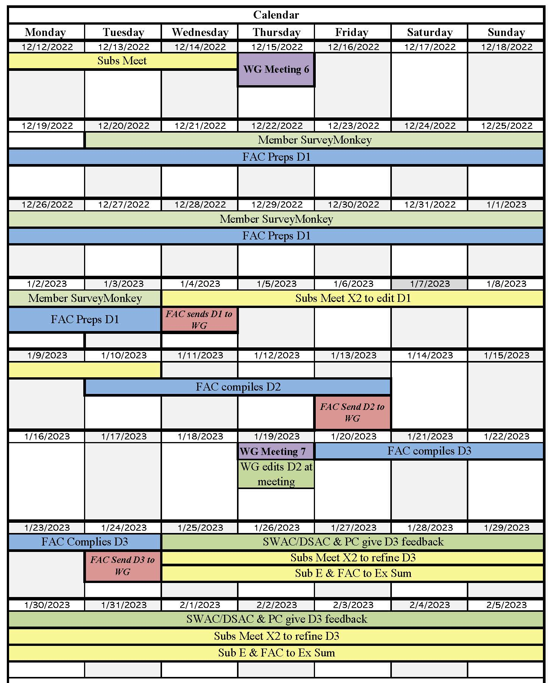
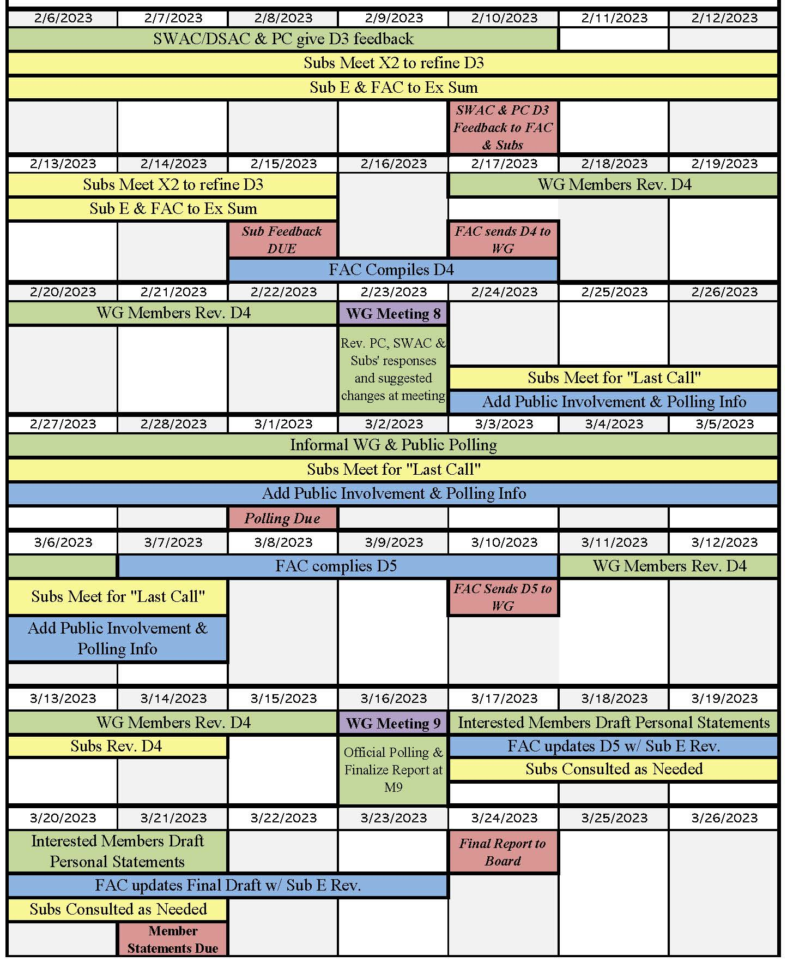

III. Workgroup Meeting Topics
Meeting Summaries and be found on the Project’s Website Here
- Meeting One: September 8, 2022, Main Topics
- Welcome & Introductions
- Participant Meeting Instructions
- Participant Commitments
- How We Got Here
- Review Major Charter Sections:
- Collaboration 101 Training
- Public Comment
- Triage Charge Elements
- Draft Report Structure Explore Common Understandings Section
- Mechanics: Add Representative Table
- Next Steps

- Meeting Two: September 15, 2022, Main Topics
- Welcome & New Member Introductions
- Participant Meeting Instructions
- Participant Commitments
- Approve Draft Minutes from Meeting One
- Public Comment
- Meeting One Evaluation Highlights
- Homework Highlights
- Explore Common Understandings & Refine List of Missing Topics/Questions
- Discuss SWMP Table of Contents Concept
- Triage Charge Elements/Workplan
- Next Steps

- Landfill Tour: September 24, 2022
- Republic (Ian) gave agenda, safety, & scale liner model speech.
- At the top of Coffin Bute hill observed the dumping area and machinery, observed the self-tipping/emptying trailers, and discussed the gas pump vacuum system.
- At an overlook of the quarry had Q&A time.
- At the power plant a CPI representative (Roman Gillan) spoke about PNCG Power owning this landfill power plant, and the Facility Manager (Steve King) gave an overview of the facility.
  - The tour was split into two groups to view the generators and interior of the power plant.
- Neighborhood Tour: October 1, 2022

- Joel (tour guide) began with some geology, local history, and comments about the community. Then Joel and Nancy provided comments on topics including bird watching, disc golf, airport for model airplanes, North Palestine Baptist church, Santiam Christian school, local geology, and fault lines
- At a stop three miles from the landfill discussed tree cover and property siting.
- As the tour moved to the archie rang the discussion covered vehicle traffic, Yamhill landfill, Red Barn Farm, composting facility, WWII maintenance shed, zoning, land use, terracing v. continuous slope, vegetated or productive slopes, settling and gasification process, zoning, and siting of landfills.
- The tour stops at, and discusses, Bit-By-Bit Horse Farm.
- When viewing the quarry the discussion focuses on the leachate facility, republic’s office, invasive species, properties purchased by landfill, OSU beef ranch, monitoring wells and water contamination.
- At the Santiam Christian School, Kevin Higgins, a firefighter with the Sherriff’s office gave a talk on growing up in the area, landfill fires, types of items in landfill, and DEQ. This was followed by a video testimony from Priya Tucker, of Rising Joy Flower Farm, and resident Elisabeth Pott.
- The discussion on the bus ride back focused on affordable housing and local buildings.

- Meeting Three: October 6, 2022, Main Topics
- Welcome & New Member Introductions
- Review Participant Meeting Instructions & Agenda
- BOC Presentation
- Approve Draft Minutes: Last Meeting & Tours
- Landfill Tour Questions
- Public Comment
- Comments on Meeting Two Evaluation Suggestions
- Discuss County Counsel Deference Memo & Set Stage for Legal Subcommittee
- Check-in Activity
- Big Picture Discussion
- Stand-Up the Subcommittees
- Review Amended Workplan
- Next Steps

- Meeting Four: October 27, 2022, Main Topics
- Welcome & New Member Introductions
- Review Participant Meeting Instructions & Agenda
- Approve M3 Draft Minutes
- BOC Action on Updated Workplan
- Public Comment
- Update on Tour Questions & Answers
- SMMO Values & Goals Discussion
- Q&A Session with Representatives from other Counties
- Subcommittee Reports
- Next Steps

- Meeting Five and Open House: November 17, 2022, Main Topics
- Welcome
- Review Participant Meeting Instructions & Agenda
- Approve M4 Draft Minutes
- Approve Updated Tour Q&A
- Updated Workplan Facilitator 11/16/22
- Public Comment
- Subcommittee Reports
- Reintroduce Charges D & E
- Next Steps
- Open House

- Meeting Six: December 15, 2022
  - Welcome & New Member Introduction
  - Review Agenda
  - Member Shares Original Document
  - Public Comment
  - Subcommittees A.1. & E.1. Report
  - Review & Approve M5 Minutes & Evaluation Summary
  - Discuss Consultant/Attorney for Next CUP
  - Subcommittee A.2 Report and A.3 B.1 Report
  - Introduce & Approve Third Attorney with Poll
  - Subcommittee C.1. Reports
  - Updated Project Workplan
  - Next steps

- Meeting Seven: January 9, 2023
j. Meeting Eight: February 23, 2023
i. Meeting Nine: March 16, 2023
IV. Subcommittees
At the third Workgroup meeting (October 6, 2022), the Workgroup identified five Subcommittees that would take on various parts of the Charter elements, consistently reporting back to the Workgroup as they progressed. This was done so specific Charter elements could be addressed at the level of depth deemed necessary by the Workgroup by those with the most expertise and investment. Once formed, each Subcommittee met roughly twice between each Workgroup meeting. The information surrounding these Subcommittees (such as charge, members, and key work products) can be found here. For more detailed information and meeting recordings please see the Subcommittees respective webpages, linked below. Specific Charter Elements were assigned to each Subcommittee as noted below.
            - Landfill Size/Capacity/Longevity: Webpage Link
Charge: A chronological history of key Coffin Butte Landfill topics:
- Size
- Specific locations
- Assumptions (e.g. when will the landfill close?)
Members:
- Bill Bromann
- Brian May
- Chuck Gilbert
- Daniel Redick
- Ginger Rough
- Ian Macnab
- Ken Eklund
- Mark Yeager
- Paul Nietfeld
- Shane Sanderson
- Staff: Daniel Redick
Subcommittee Meetings and Notes: Document Link
            - Past Land Use Application Conditions: Webpage Link
Charge: A chronological history of key Coffin Butte Landfill topics:
- Conditions of past land use approvals;
- Compliance with prior land use approvals and SWMP;
Members:
- Catherine Biscoe
- Ed Pitera
- Jeff Condit
- Mark Yeager
- Staff: Inga Williams
Subcommittee Meetings and Notes: www.co.benton.or.us/sites/default/files/fileattachments/community_development/page/8322/master_doc_of_committee_meetings-12-13.pdf

            - Sustainable Materials Management Plan (SMMP): Webpage Link
Charge:
Long Term Sustainable Materials Management Plan (SMMP) tasks:
  - Contracting out;
  - Subjects to be covered;
  - (Moved from Common Understandings) Benefit-Cost Topics are only Outlined
  - (New) Add in Vision 2040 and related County documents with similar from other counties referenced
  - Who needs to be at the table beyond those in the County;
  - A workplan outline with a timeline for completion;
  - Topics covered in recent similar planning efforts across the state; and
  - What “lessons learned” should be brought forward in this process. Includes necessary foundational “common understandings” and protocols needed before beginning the actual planning process.
NOTE: This charge does not include completing the plan. It only includes a discussion of the preliminary scoping to start that planning process Possible Amendment for BOC Consideration: If there is sufficient time to complete the original Charge and the following activities, subcommittee to provide recommendations on: 1. the most important topics/subjects from the draft of the SWMP Table of Contents; 2. the brainstormed options for those topics/subjects; and 3. the reasoning, both pro and con, for their selection.

Members:
    - Brian May
    - Daniel Redick
    - Joel Geier
    - John Deuel
    - Ken Eklund
    - Marge Popp
    - Ryan McAlister
    - Sean McGuire
    - Staff: Daniel Redick
Subcommittee Meetings and Notes: Document Link
            - Legal Issues and Land use Review: Webpage Link
Charge A: A Summary of the County’s current rights and obligations to Republic Services, and vice versa, surrounding:
- The hauling franchise;
- The landfill CUP; and
- What legally can and cannot be conditions of any land use approvals (e.g. past compliance, compliance with future laws, codes, and policies, DEQ compliance, reopening, limitations on what can be brought into the County from where, required facilities and practices, reporting/compliance/financial monitoring requirements, etc.)
- Interpretation and Deference: A Summary of the rights and obligations of other entities surrounding landfills, hauling, and sustainability initiatives, etc.:
      - Federal;
      - Tribal;
- State (e.g. Is DEQ prohibited from permitting another landfill west of the Cascades and what does the “regional landfill” designation mean?);
- Local Government; and
- Summary of the step-by-step process in ORS chapter 459 and associated timing for the cross-jurisdictional approvals of landfill applications, (e.g. DEQ) including:
      - What topics are within whose authority, and
      - Whether, for example, the County can or should consider the topics it does not have permitting authority over when assessing the criteria outlined in Code section 53.215?
Charge B: Land Use Review Tasks:
- Create a common understanding document outlining which Development Code criteria are applicable to the review of a conditional use application for landfill expansion by reviewing:
      - 53.215 (Criteria)
      - 77.305 (Conditional Uses)
      - 77.310 (Review)
      - 77.405 (DEQ)
- Review Chapters 50 and 51 for context, and then prepare a conceptual list of any other Development Code criteria the WORKGROUP recommends be applicable.
- Developing recommended guidelines for interpreting any ambiguous provisions recognizing current statutes, regulations, case law, and County precedent, etc. In doing so, refer to Comprehensive Plan for policy guidance regarding interpretation of any ambiguous Development Code provisions (see, BCC 50.015,) and Review the Planning Commission comments made during its last review of Republic Services’ CUP application for context. Examples for consideration include:
      - The phrase, “Other information as required by the Planning Official” 77.310(e)
      - The terms found in Section 53.215, e.g.
      - “seriously interfere”
      - “character of the area”
      - “purpose of the zone”
      - “undue burden”
      - “any additional criteria which may be required for the specific use of this code.
      - Other: ____________
- Necessary Tasks to Start Planning Reopening of Existing Hauling Agreement
- Roles, Responsibilities, and Protocols of SWAC and DSAC
- Specific Recommended Review Criteria for the Evaluation of Landfill CUP applications
- SWAC/DSAC, Planning Commission, and BOC Use of the Review Criteria
- Future Timeline for Discussing any Needed Changes to the Benton County Code Flowing From WORKGROUP Recommendations
- Recommendations
Members:
- Jeff Condit
- Liz Irish
- Vance Croney
- Staff: Greg Verret
Subcommittee Meetings and Notes: Document Link
            - Community Education and Public Involvement Summary: Webpage Link
Charge:
- General History:
  - Directed at public and those new to the issue
  - Not as detailed as initial draft
  - Narrative more than table of newspaper articles
  - Other historical details will appear in the Capacity and CUP reports for cross-referencing.
- Next CUP Communications Protocols:
  - Start with legal requirements from Legal Subcommittee
  - Develop protocols for the timely and broad distribution of CUP-related information to the public, other governmental entities, and internal committees, groups, and divisions.
  - Look at wide distribution via multiple communication channels
  - Note opportunities for input from the jump
  - Possible Open House/Community Forum events
  - Benton County devoted website with public comment email/form, Etc.
  - Legal Issue: Apply to just landfill CUP or all CUPs – perhaps, two processes; one for big/large area impacts vs. smaller/localized impacts, etc. May require code amendments.
- Executive Summary:
  - Emphasis will be on recommendations
  - Note where “consensus” and MAJ- MIN
- Community Education Plan:
  - Focus on the ending of the BCTT process and preparation for next CUP
  - SMMP info?
  - FAQs from a process perspective – not the substantive perspective
  - Outreach Plan
- Recommendations

Members:
- Ginger Rough
- Cory Grogan/ JonnaVe Stokes
- Louisa Shelby
- Marge Popp
- Mark Henkels
- Mary Parmigiani
- Staff: Amelia Webb
Subcommittee Meetings and Notes: Document Link

V. Key Workgroup Findings & Recommendations
History of Coffin Butte

SECTION A: Landfill Size/Capacity/Longevity
Introduction:

Key Findings:

Key Recommendations:

Additional Information:

- The full Subcommittees Report can be found here.

SECTION B: Past Land Use Application Conditions
Introduction:

Key Findings:

Key Recommendations:

Additional Information:

- The full Subcommittees Report can be found here.

SECTION C: Sustainable Materials Management Plan (SMMP)
Introduction:

Key Findings:

Key Recommendations:

Additional Information:

- The full Subcommittees Report can be found here.

SECTION D: Legal issues and Land use Review
Introduction:

Key Findings:

Key Recommendations:

Additional Information:

- The full Subcommittees Report can be found here.

SECTION E: Community Education and Public Involvement Summary
Introduction:

Key Findings:

Key Recommendations:

Additional Information:

- The full Subcommittees Report can be found here.

Final Polling
WORKGROUP Member | Polling | Charge | Not Here | Abstain | 1 | 2 | 3
Chuck Gilbert | X | All
Marge Popp | X | All
Elizabeth Irish | X | All
Russ Knocke | X | All but C
Shawn Edmonds | X | All but C
John Deuel | X | All
Kathryn Duvall | X | All
Christopher McMorran | X | All
Ryan McAlister | X | All
Mary Parmigiani | X | All
Ed Pitera | X | All
Louisa Shelby | X | All
Catherine Biscoe | X | All
Polling Totals: |  |  |  | 3 | 8 | 0 | 0
EX-Officio | Polling | Charge | Not Here | Abstain | 1 | 2 | 3
Brian Fuller
Brian May
Shane Sanderson
County | Polling | Charge | Not Here | Abstain | 1 | 2 | 3
Daniel Redick
Sean McGuire
Ex-Officio Totals: |  |  | 0 | 0 | 5 | 0 | 0
Grand Totals:

RESULT: Consensus / No Consensus
Minority Proposal: None
Last Meeting Transcript
Member Statement in Alpha Order or group by Support, Neutral, or don’t Support [List in Alpha Order]
Member | Affiliation | Statement Number
Audrey O’Brien | DEQ | 1
Brian May  ALT: Andrew Jonson | Marion County | 2
Catherine Biscoe | Public | 3
Christopher McMorran | Public | 4
Chuck Gilbert | SWAC/DSAC | 5
Daniel Redick | Benton County Staff | 6
Ed Pitera | Public | 7
Elizabeth Irish | Planning Commission | 8
John Deuel | Republic: Local | 9
Kathryn Duvall | Public | 10
Louisa Shelby | Public | 11
Marge Popp | SWAC/DSAC | 12
Mary Parmigiani | Public | 13
Russ Knocke  ALT: Ginger Rough | Planning Commission | 14
Ryan McAlister | Public | 15
Sean McGuire  ALT: Jen Brown | Benton County Staff | 16
Shane Sanderson | Linn County | 17
Shawn Edmonds  ALT: Julie Jackson | Republic: National | 18

VI. Public Outreach and Process Reflections
a. Public Outreach Summary
b. Member Process Evaluation Summary
c. Facilitator Process Reflections

VII. Appendix
a. Meeting Summary and Open House Topics
b. _______________
c. _______________
etc.

Appendix A: Meeting and Open House Topics
a. Meeting One: 09/08/2022
1. Main Topics
- Welcome & Introductions
- Participant Meeting Instructions
- Participant Commitments
- How We Got Here
- Review Major Charter Sections:
- Collaboration 101 Training
- Public Comment
- Triage Charge Elements
- Draft Report Structure Explore Common Understandings Section
- Mechanics: Add Representative Table
- Next Steps
2. Materials Presented
- Agenda
- Assessment
- Facilitator Observations
- Charter
- PowerPoint
- Survey Summary
- First Draft of Report
3. WORK GROUP Discussion
The workgroup reviewed the major Charter sections: these were the general scope, charge elements, guiding principles, how polling works, and the “one table” concept. The workgroup triaged the draft report structure, exploring the Common Understandings section. The major themes were refining the list of missing topics/questions, providing additional information where needed, and commenting on the next draft. When discussing the mechanics of the workgroup, the central topics were establishing meeting times, and scheduling suggestions for the landfill and neighborhood tours.
For the complete Workgroup discussion, please review the 09/08/2022 Meeting Minutes here.
The Zoom video recording is available here.
4. Action Items
Members were given the Meeting One Evaluation link. Homework for the next meeting included providing information on member alternates and submitting any final topics and/or questions with supporting materials.
The County agreed to work on increasing project visibility and public information, and expanding the interested party list in the making with those that were on the CUP process list.
5. Public Comment
Themes from Public Comments:
- Mountain of garbage. Need to keep existing capacity in mind and what this means for the County.
- Only 7% of waste comes from Benton county and should not be dumping ground for others.
- Process should focus more on SMMP – not a CUP application.
- Once a cutting-edge facility; now never-ending community problem.
- Coffin Butte a tragedy of commons; make those furthest away pay more.
- Future-orientated focus removed from the Charter – focus on more than landfilling.
- Consider options for harvesting energy from the landfill
- He workgroup is in a unique position regarding common understandings. The workgroup should get the facts and work hard to develop common understandings. This could be a worthy outcome in and of itself.
b. Meeting Two: 09/15/2022
1. Main Topics
- Welcome & New Member Introductions
- Participant Meeting Instructions
- Participant Commitments
- Approve Draft Minutes from Meeting One
- Public Comment
- Meeting One Evaluation Highlights
- Homework Highlights
- Explore Common Understandings & Refine List of Missing Topics/Questions
- Discuss SWMP Table of Contents Concept
- Triage Charge Elements/Workplan
- Next Steps
2. Materials Presented
- Agenda
- Draft 9/8/22 Minuets
- Comments
- Meeting One Evaluation
- Homework Summary
- Common Understandings Table of Contents
- SWMP Table of Contents
3. WORK GROUP Discussion
Sam shared the results and explained how the evaluations and homework answers are compiled. Amelia pulls comments from SurveyMonkey and formats it for ease of review. The workgroup then had a brief discussion about fairness and balance. Important themes from exploring the Common Understandings Section and the SWMP include emphasizing that the workgroup’s current purpose is to grow a full list of topic (not to finetune or get precise placement), brainstorming different areas of questioning. The workgroup then triaged the Charge Elements/Workplan. The overarching theme was flushing out what the workgroup has the ability and resources to do.
For the complete Workgroup discussion, please review the 09/15/2022 Meeting Minutes here.
The Zoom video recording is available here.
4. Action Items
Members were given the Meeting Two Evaluation link, and tour updates were given. Homework for the next meeting included members track changing the Charge Common Understandings and SMMP Table of Contents with any topics/questions they think are missing.
5. Public Comment
- Paul Nietfeld (engineer and resident living between Corvallis city limits and the landfill): Issues: Historic intake for coffin butte. Shows a graph with landfill input and a table with projections for landfill life, including Cell 6. Quarry challenge. Shared a desire to document intake, life, and quarry in a final report.
- Sam’s shared an example about assumptions used by different parties and the need to test them collaboratively. The use of sensitivity analyses.
- Ryan McAlister adds that life events make landfill input ebb and flow.
- Chuck Gilbert: Referenced the memo submitted on sustainability & looking at the landfill as a resource, and encouraged the members to read it.
- Ken Ekland: Followed up on Paul’s presentation. He had concerns about volume numbers in the report/document being incorrect, so the lifespan Paul predicted may be too generous. Shared comments on the history of the Solid Waste Advisory Council (SWAC) and the Disposal Site Advisory Committee (DSAC.)
- Brian Fuller also shared comments on the topic of comparing the different assumptions and metrics used by different groups.
- A subcommittee should be set up so people from different groups can discuss these assumptions and then present them together to the workgroup. Sam also encourages people to send in additional written comments on these topic.

c. Meeting Three: 10/06/2022
1. Main Topics
- Welcome & New Member Introductions
- Review Participant Meeting Instructions & Agenda
- BOC Presentation
- Approve Draft Minutes: Last Meeting & Tours
- Landfill Tour Questions
- Public Comment
- Comments on Meeting Two Evaluation Suggestions
- Discuss County Counsel Deference Memo & Set Stage for Legal Subcommittee
- Check-in Activity
- Big Picture Discussion
- Stand-Up the Subcommittees
- Review Amended Workplan
- Next Steps
2. Materials Presented
- Agenda
- Draft 9/15/2022 Minutes
- Landfill Tour Minutes & Landfill Tour Questions
- Neighborhood Tour Minutes & Neighborhood Tour Questions
- Meeting Two Evaluation
- Email Attachment Comments
- County Council Deference Memo
- Common Understandings Table of Contents with Track Changes
- SWMP Table of Contents with Track Changes
- CUP Conditions with Track Changes
- Member Memo
- Republic Memo: Section 2 C and Section 3
- Charge C
- Charge B
3. WORK GROUP Discussion
The workgroup discussed what to do with the mass amount of emails that get sent between meetings. Between meeting one and two it was roughly 1,600 emails. Many of these emails focused on understanding Charge b, so a legal subcommittee to present to the group on what the law was proposed. The big picture process discussion emphasized that the workgroup is engaging in a bridge process that will set the stage for subsequent processes and decisions. The subcommittees to stand up are as follows:
- Landfill Size/Capacity/Longevity Subcommittee (Existing)
- CUP Conditions Subcommittee (Existing)
- Law Subcommittee (Pending)
- Land Use Law 101
- Deference Memos
- Rights and Obligations
- Entity Rights and Obligations
- Reporting Requirements
- Potential SWMP Subcommittee and Potential Amendment Request to BOC
For the complete Workgroup discussion, please review the 10/06/2022 Meeting Minutes here.
The Zoom video recording is available here.
4. Action Items
Members were given the Meeting Three Evaluation link. The facilitation team will schedule and conduct the subcommittee meetings before the next workgroup meeting. County staff will organize and add additional materials to the discussed documents and present them to the workgroup at the next meeting. Republic also committed to responding to tour questions for the subcommittees to review.
5. Public Comment
- Audrey Sterling (Community Member): Reflects that the talk in the community focuses on the idea that the landfill is full and what to do with the trash. They need to find a place for it so the landfill does not overflow.
- Kristen Mitchell (Executive Director of Oregon Refuse & Recycling): Explains what her company does, noting that Coffin Bute is in very good standing. She also notes that because Senate Bill 882 was passed, RMA should come into effect soon
- Cris Reese (Community Member and Small Business Owner): Expresses appreciation for the work Republic does at Coffin Bute and notes he does not want small businesses to be forced to pay garbage trucks to haul longer distances.
- Chuck Gilbert (Community Member): Comments on how the landfill and rock removal are both valuable resources.
- Jennifer Holworth (Community Member): Reflects positively on Republic’s compost and recycling programs.
d. Meeting Four: 10/27/2022
1. Main Topics
- Welcome & New Member Introductions
- Review Participant Meeting Instructions & Agenda
- Approve M3 Draft Minutes
- BOC Action on Updated Workplan
- Public Comment
- Update on Tour Questions & Answers
- SMMO Values & Goals Discussion
- Q&A Session with Representatives from other Counties
- Subcommittee Reports
- Next Steps
2. Materials Presented
- Agenda
- Draft M3 Minutes
- M3 Evaluation Summary
- Updated Workplan
- Public Comments Document
- Member Comments Document
- BCTT Tour Questions 10/25
- SMMP Values & Goals Presentation: 2040 Initiative History & Overview
- Charge C
- A.1 Subcommittee Report
- A.2 Subcommittee ____
- A.3 Subcommittee Webpage
- C.1. Subcommittee Report

3. WORK GROUP Discussion
The Facilitator reviewed the agenda, M3 Minutes, and updated workplan. The minutes were approved and the only significant change to the BOC Action and Workplan was more time was added between the Workgroup meetings, so there is time for subcommittees to meet. After the public comment, the group went over the updated Tour Questions - Joel requested they be changed so it does not appear that the neighborhood leadership neglected to respond to Republic tour questions. Sean then presented on the SMMP Values & Goals with coverage of the 2040 Initiative, including History & Overview. Daniel had previously reached out to other Counties so they could talk about the issues/topics they have been dealing with. Key takeaways from this discussion:
- Public engagement is critical, especially with the SWMP or SMMP.
- Subcommittees can be very effective
- The Recycling Modernization Act should be front and center
- They should consider different housing types. EX: Multi-family homes have different recycling resources. How can you still support these homes?
- Remember that solid waste is a transportation issue.
- Keep in mind changing technologies (EX: JUNO)
- Recycling is vital to the transient community. It is an equity issue.

Subcommittee reports were given to the group and there was discussion on ways to improve their action plans.
For the complete Workgroup discussion, please review the 10/27/2022 Meeting Minutes here.
The Zoom video recording is available here.
4. Action Items
Members were given the Meeting Four Evaluation link. The facilitation team will continue scheduling and conducting the subcommittee meetings with County staff. The discussion of applying Values to the CUP will be added to the agenda for the next applicable meeting. Staff and the Facilitation team will plan and communicate to members the plans for the Open House element of Workgroup Meeting Five.
5. Public Comment
- Doug Pollock (neighbor of the landfill, engineer, and parent): He explained how he documented that inkjet cartridges being sent to the landfill from HP were leaking ink into the landfill as they were crushed by landfill equipment. In response he helped develop a recyclable ink cartridges program which processed 200 tons of cartridges in its first year, half of that being ink. He also discussed how Corvallis public schools have been resistant to recycling and continue to put hazardous materials such as fluorescent tubes and epoxy into bins going to the landfill. Essentially, there is no audit of what is going into the landfill. He also emphasized that these consensus processes are hard for the real public to get involved with and be heard. He said these processes tend to favor process insiders more than the public.
- Debbie Palmer (resident) 11/16/22 Submittal: [She] expressed her opinion that the facilitator misrepresented the neighbors as wanting to close the landfill as soon as possible. She elaborated that the neighbors just want it to stop expanding, and that the County should take the estimated 10-15 years of landfill life left via already-permitted airspace to plan for post-closure waste management. She also noted the difference between intentionally-sited and accidentally-sited landfills, pointing out that Coffin Butte is an accidentally-sited one, and commented that since Republic Services profits substantially from landfilling garbage, they have no incentive to pursue alternatives to landfilling. She summarized that she felt everyone wants to do something to combat the climate crisis, and that working towards eventual closure of the landfill would help.
- Linda Brewer (resident, soil scientist, and ten-year member of SWAC): stated that, in her opinion, Republic is doing a good job managing the landfill. She also noted that the Benton County trash rate has been held artificially low.
- Pat Schwartz (resident): expressed the belief that the Republic is an important part of the community.
- Cat Newsheller (resident): expressed the belief that Republic is simply trying a new tactic to get what they want – expanding the landfill and taking in more trash. She feels that Republic should not be making money off people's health, and if the County lets them expand, they will become out of control. She also shared personal experiences concerning the traffic and debris on HWY 99 from landfill trucks.
- Dale Elizabeth Draeger (resident): explained that they recently visited the landfill and were concerned that people were throwing away recyclable materials like metal. Republic should have someone to monitor the sorting.
- Pat Hare (City Manager of Adair Village): Pat reflected on their positive experiences working with Republic and noted that they are a large employer in the community. He also notes that when the cost to get rid of trash increases, more trash ends up on the street.
- James Rodell (resident, but not close to the landfill): He would like clear and transparent communication on whether Republic broke certain agreements and the consequences.

e. Meeting Five
1. Main Topics
- Welcome
- Review Participant Meeting Instructions & Agenda
- Approve M4 Draft Minutes
- Approve Updated Tour Q&A
- Updated Workplan Facilitator 11/16/22
- Public Comment
- Subcommittee Reports
- Reintroduce Charges D & E
- Next Steps
- Open House
2. Materials Presented
- Agenda
- Draft M4 Minutes
- M4 Evaluation
- Tour Q&A Final Version
- Updated Workplan
- Public Comments
- Public & Member Comments (passcode: Benton1!)
- A.1. Subcommittee Report
- A.2. Subcommittee Homepage
- A.3. & B.1. Subcommittee Homepage
- C.1. Subcommittee Report
3. WORK GROUP Discussion
Joel Geier introduces a motion to revise the M4 notes as per the recent email exchange, which Ed Pitera seconds. Ed also suggests alternative ideas like using a transcript. Sam holds a quick poll on the original motion: Substituting the language that Joel Geier presented in place of the existing Doug Pollock comments in the Public Comments section of the Meeting 4 Minutes. (See Polling Issue 1, below, and 07:53 – 10:00 of meeting recording). Sam responds to the alternative ideas raised by Ed, and suggests that people can bring in written statements if they would like or send in a written statement the next week to encapsulate the comment they made at the Workgroup. This is viewed favorably by the workgroup. Daniel explains how the comments are currently accessible on the meeting agendas via FTP’s, and the Tour Q&A and Project Workplan updates are approved.

Subcommittee reports were given to the group and there was discussion on ways to improve their action plans.
For the complete Workgroup discussion, please review the 11/17/2022 Meeting Minutes here.
The Zoom video recording is available here.
4. Action Items
Members were given the Meeting Five Evaluation link. The facilitation team will continue scheduling and conducting the subcommittee meetings with County staff, and subcommittee E will be formed and begin meeting. Notes created from the open house will be prepared for presentation at the next meeting.
Polling Issue 1: Substituting the language that Joel Geier presented for Doug Pollock’s current comments in the Public Comments section of the Meeting 4 Minutes.
WORKGROUP Member | Polling | Charge | Not Here | Abstain | Yes | No
Joel Geier | X | All |  |  | X
Marge Popp | X | All |  | X
Elizabeth Irish | X | All |  | X
Russ Knocke | X | All but C |  |  | X
Shawn Edmonds | X | All but C |  | X
John Deuel | X | All |  |  | X
Kathryn Duvall | X | All | X
Christopher McMorran | X | All | X
Ryan McAlister | X | All |  |  | X
Mary Parmigiani | X | All |  |  | X
Ed Pitera | X | All |  |  | X
Louisa Shelby | X | All |  |  | X
Catherine Biscoe | X | All | X
Polling Totals: |  |  |  | 3 | 7 | 0
EX-Officio | Polling | Charge | Not Here | Abstain | Yes | No
Brian Fuller |  |  |  | X
Brian May |  |  | X
Shane Sanderson |  |  |  | X
County | Polling | Charge | Not Here | Abstain | Yes | No
Daniel Redick |  |  |  |  | X
Sean McGuire |  |  |  | X
Ex-Officio Totals: |  |  |  | 3 | 1 | 0
Grand Totals: |  |  |  | 6 | 8 | 0

RESULT: Consensus / No Consensus
Facilitator counts a Majority, so the group is going to move forward with making the changes.
Minority Proposal: None
5. Public Comment
- Schmidt Pathman: His company promotes research on Solid Waste Management and partners with Universities, national, and international organizations. Some of their concerns about landfills are: 1) the underestimation of methane produced by landfills and lessoning organic materials thrown away, and 2) lessening cross contamination of recyclable materials, which can be better achieved with the sorting system they have designed. (Pending receipt (full statement) by speaker to be placed in Appendix A of Meeting Minutes.)
- Debbie Palmer: Notes that the link to the FTP links is only good for a month. She also notes that she likes the need for fidelity between the oral and written public comments.
- Daniel: Explains that, yes, the links need to be reset each month. However, they will ensure the links are always updated and available.
- Dr. Skip Rochefort: (Associate Professor of Chemical Engineering at Oregon State University) He presents a recorded lecture/slideshow on how they have created a way to create diesel fuel from plastics using only heat. (See Appendix B of Meeting Minutes for slideshow).
f. Meeting Six
1. Main Topics
  - Welcome & New Member Introduction
  - Review Agenda
  - Member Shares Original Document
  - Public Comment
  - Subcommittees A.1. & E.1. Report
  - Review & Approve M5 Minutes & Evaluation Summary
  - Discuss Consultant/Attorney for Next CUP
  - Subcommittee A.2 Report and A.3 B.1 Report
  - Introduce & Approve Third Attorney with Poll
  - Subcommittee C.1. Reports
  - Updated Project Workplan
  - Next steps
2. Materials Presented
- Working M6 Agenda
- Draft M5 Minutes and Open House Notes
- M5 Evaluations
- Comments
- Topic A.1. Landfill Capacity/Longevity
- E.1 Community Education
- Topic A.2. Past CUP Conditions
- A.3. Legal Issues and Topic B.1. Land Use Review
- Legal Subcommittee PPT
- Legal Subcommittee Statement
- Virginia Gustafson Lucker Resume
- C.1. SMMP
- BCTT Draft Workplan Gantt Chart
- BCTT Draft Workplan Calendar
3. WORK GROUP Discussion

For the complete Workgroup discussion, please review the 12/15/2022 Meeting Minutes here. The meeting recording can be found here.
4. Action Items
Members were given the Meeting Six Evaluation link. The facilitation team will continue scheduling and conducting the subcommittee meetings with County staff, an Informal Member Survey will be sent out for Members to complete over the holiday, and facilitation staff will begin drafting the first draft of the final report.
Polling Issue 1: Virginia (Ginny) Lucker will join the Legal Subcommitee to serve as the neutral “third leg of the stool.“
WORKGROUP Member | Polling | Charge | Not Here | Abstain | 1 | 2 | 3
Chuck Gilbert | X | All |  |  | X
Marge Popp | X | All | X
Elizabeth Irish | X | All |  |  | X
Russ Knocke | X | All but C |  |  |  | X
Shawn Edmonds | X | All but C |  |  |  | X
John Deuel | X | All |  |  | X
Kathryn Duvall | X | All |  |  | X
Christopher McMorran | X | All | X
Ryan McAlister | X | All | X
Mary Parmigiani | X | All |  |  | X
Ed Pitera | X | All |  |  | X
Louisa Shelby | X | All |  |  | X
Catherine Biscoe | X | All |  |  | X
Polling Totals: |  |  |  | 3 | 8 | 0 | 0
EX-Officio | Polling | Charge | Not Here | Abstain | 1 | 2 | 3
Brian Fuller |  |  |  |  | X
Brian May |  |  |  |  | X
Shane Sanderson |  |  |  |  | X
County | Polling | Charge | Not Here | Abstain | 1 | 2 | 3
Daniel Redick |  |  |  |  | X
Sean McGuire |  |  |  |  | X
Ex-Officio Totals: |  |  | 0 | 0 | 5 | 0 | 0
Grand Totals: |  |  | 3 | 0 | 13 | 2 | 0

RESULT: Consensus / No Consensus
Minority Proposal: None
5. Public Comment
- Camille Hall: (Resident) She is sad that the Board chose to remove Nancy, and now, Joel. These members have unique experiences and knowledge that was valuable. The County currently does not have a process to deal with the tons of trash that go into the landfill. She understands that the two removed people had complained about the facilitator and commissioners and is saddened they chose to remove them.
- Debbie Palmer: (Resident) Question: Who, in the end, will be writing the SMMP? Who will write the RFP? Darren: Answering - He does not know for sure, but staff will put together a draft RFP to hire the consultant. They may ask the Board and maybe some Subcommittees / WG if appropriate. They are looking at other counties’ successful plans, and they are invested in getting it right.
- Tom Hewes: (Resident since 1974.) He seconds Camille’s statement and is also extremely disappointed in the facilitator and the County for removing the two members. Question - How does having the second biggest landfill on OR align with the Country's values?
- Kate Harris: (Lives in Soap Creek and kids go to school in Adair Village) Thanks the group for being here. Explains that the Adair Village water source is in an area that gets contaminated by the landfill. The contaminants go to the Corvallis treatment plant, but how do we know the water from the park is getting cleaned for all the things? What is the filtration process? We know fires at the landfill, earthquakes, even air quality is starting to be tracked, but water is a big issue too. She hopes the focus can be on minimizing the landfill need. How can we move landfill storage to drier climates, so they are not so hazardous?
- Ron Thompson: (From Newport and is a third-generation garbage disposal business.) Wants to share his concerns if Coffin Butte were to close. It is expensive to haul stuff farther away, more emissions from trucks, and more wear on roads. They also had rates go way up when their local landfill closed, and as they already have a notable dumping problem, raising rates so people cannot afford it would make things worse. He would love to recycle everything, but landfills are an important and needed tool.
- Marge Popp: (Workgroup Member) She is also disappointed that Nancy and Joel were removed. They were hardworking and knowledgeable - and while they could challenge authority, she wishes that their positive qualities could have been more prioritized.
- Brain Fuller: (DEQ Workgroup Member) lets folks know he is retiring from DEQ, and that Audrey O’Brien will be replacing him. Audrey then introduced herself and shared some of her background at DEQ.
g. Meeting Seven
1. Main Topics
2. Materials Presented
3. WORK GROUP Discussion
4. Action Items
5. Public Comment
h. Meeting Eight
1. Main Topics
2. Materials Presented
3. WORK GROUP Discussion
4. Action Items
5. Public Comment

