**Report to the BCTT Workgroup by the BCTT Subcommittee – E.1. Community Education**

**December 15, 2022**

**A. Landfill History Section**

Section Drafters: Marge Popp, Mark Henkels

**Guiding Concepts for Writing this Section**

1) The existing timeline built from newspaper articles will be an appendix.

2) A timeline will be created that reflects the history of the area, the rising need for a landfill system in Benton County and the region, when Coffin Butte became a landfill site, and the major points in the history of ownership, operation, oversight and permitting of the landfill.

3) We envision an easily readable narrative of 10-15 pages, plus the timeline.

4) The environmental and historical context of the Coffin Butte area will be briefly discussed.

5) The focal concerns with be how Benton County and the region settled on Coffin Butte as their major landfill site, how ownership and operations of the landfill changed over time, key aspects of how Benton County and the state have done oversight and permitting regarding the site, and key times of public concern regarding the landfill.

6) The history will refer to relevant information from other parts of the larger report and the indices.

**We request feedback on the following concerns:**

1. How long should the history be?
2. Are there specific aspects of the history or geography we should include?

3) We plan to cite all materials used. As long as we have authors’ permissions or the documents are public records with no copyright issues, can we use whatever materials we can discover?

**B. Notification/Communications Section**

Drafters: Louisa Shelby and Mary Parmigiani

1. Create clear recommendations on the “best practices” for County communication with the public for the next CUP. (During the last CUP process some of the neighbors did not feel the County communicated effectively.)

* These recommendations will be created by examining the minimum requirements for public communications (See attachments from Legal Subcommittee pending link), and the list of current County methods for public outreach (provided by Corey
* Subcommittee E will present their recommendations to the Workgroup. Once finished, the Workgroup recommendations will be given to the Board.
* These recommendations could also apply to future communications concerning the SMMP.

2) Create a community outreach plan for the County to use going forward to wrap up the BCTT process and communicate future developments like the CUP, Franchise negotiations, and the SMMP RFP, etc.

a. This includes

* Telling the public what the Workgroup has done
* Proving information on FAQs that relate to the Workgroup process
* Giving the public a picture of what communication will look like for the next CUP and SMMP

**Documents Used:**

1. “Benton County Talks Trash” Solid Waste Process Workgroup Survey Outreach Plan
2. Link: <https://docs.google.com/document/d/1KW5YW7CSkArwAsKf8uQ4rgEFRWu4sHyk/edit>

|  |  |  |  |
| --- | --- | --- | --- |
| **Benton County Talks Trash Notifications Draft Chart** | | | |
| **Notification Subject** | **Notification Type** | **Who is Notified** | **Timeline** |
| BCTT Report | Email blast  SWG Interested Parties List, Organic Subscribers, make sure those who spoke at meeting are on the list  Soap Creek Neighbors Group, other landfill neighbors | Everyone "X" Miles from Landfill  750 ft  5-mile radius  10-mile radius  15- mile radius  (See visuals below) | * 48 hours? * 72 hours?   After report if finished |
| BCTT Survey re: Public thoughts on workgroup report | Email blast, website post.  Possible postcard to the entire county here with a link to go to and/or scan to get on a list to be informed of further updates and/or have an open house event/public informational meeting- weekend in the daytime where the link and email list is available. | Entire County | Open 1 month |
| Board Hearing on Report | Email blast, website post | Everyone 10 Miles from Landfill | 24 hrs. after scheduled |
| CUP Filing | Post Card, email blast, newspaper | Entire County | 24 hrs. after initiation |
| CUP Completion | Email blast, website post, newspaper | Entire County | 24 hrs. after |
| Planning Commission Meetings | Post Card, website post (post card could be too expensive) | People on existing email list | 2 weeks before meeting |
| SWAC Meetings | Website, email to interested groups | People on existing email list | 1 to 2 weeks before meeting |

**General Notes**

1. If any codes are changed or affected by the BCTT Sub Committee E suggestions, it would be recommended they apply to all similar types of CUP applications, not just Republic.
   1. However, we should have a tiering list for small, medium, and large CUP applications (more communication for larger ones that are more influential, less communication for smaller CUP applications)
2. Also, should keep in mind transportation corridors for who we notify.

1. Goal is to err on the side of notifying more people, then less people and to notify and involve the public in advance of CUP submission for input.
2. We had a consensus on the postcard idea, still needing to get information on how much money that would be.
3. With the notification channels that the county sent us we noticed that for people that aren’t following Benton County, or aren’t already plugged into what the county is doing they aren’t getting any information, because of this we are also trying to initiate the contact (like with the postcard) and then provide an option on that postcard for people to get more involved
4. From looking at the visuals, how large should the radius be for communication? **(ask workgroup)** Options are: 750ft which is the existing one, 5 miles, 10 miles, 15 miles or some other distance.
5. The subcommittee has agreed that 750 ft seems way too small

**Circles for around Landfill Visual**

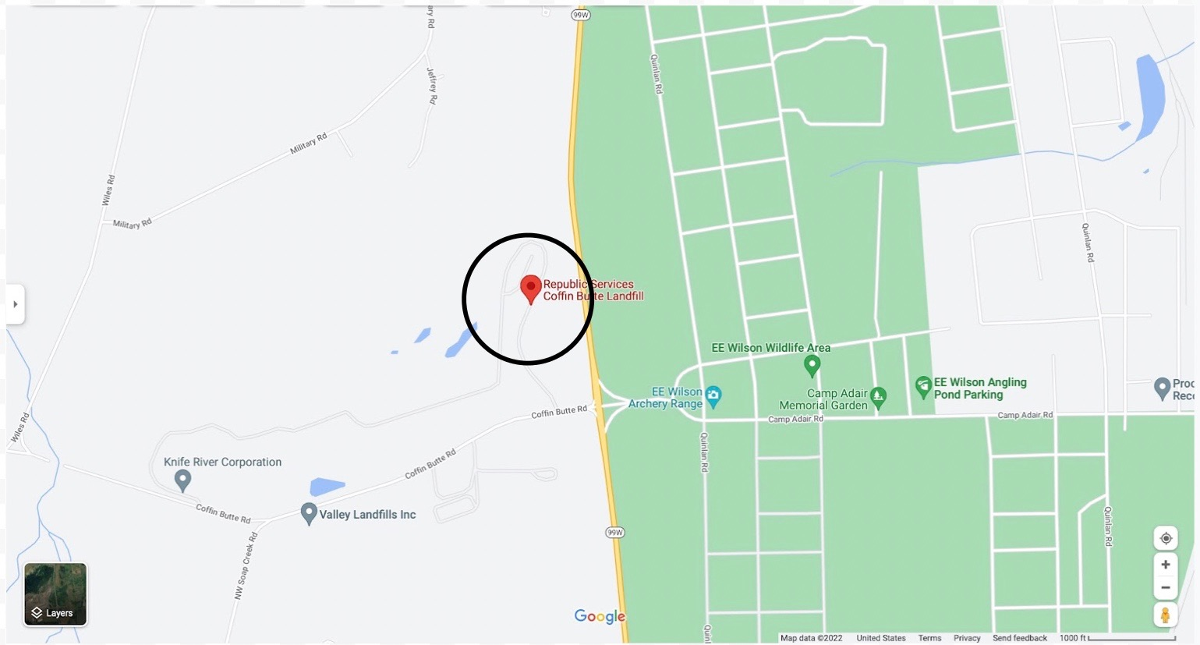

~750 ft radius

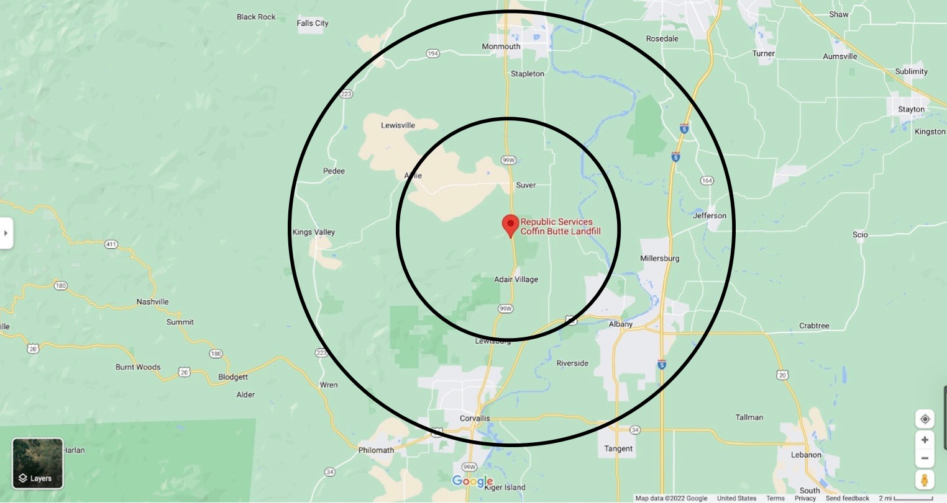

~Smaller Circle is ~5-mile radius, Larger Circle is ~10-mile radius

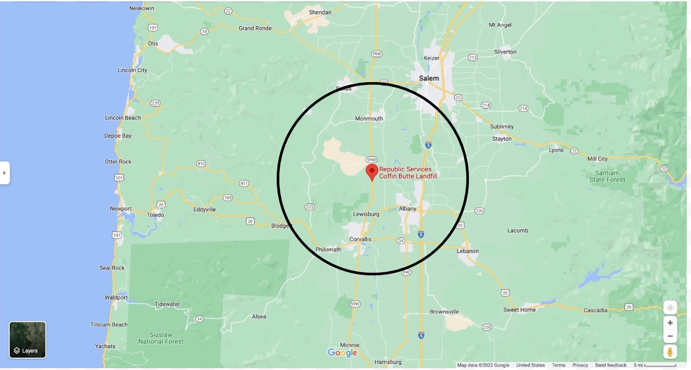

~15-mile radius